Timpanogos Special Service District
Project ID: CEEn_CPST_03

by

Tetrahedral Associates
Sarah Jaen McClellan
Braden Vance
Cat Calancea
Derek Warren

A Capstone Project Final Report

Submitted to

Matt Dalton
Lehi City

Department of Civil and Construction Engineering
Brigham Young University

April 6, 2022
Executive Summary

PROJECT TITLE: Timpanogos special service district
PROJECT ID: CEEn_CPST_003
PROJECT SPONSOR: Lehi City
TEAM NAME: Tetrahedral Associates

BYU Capstone Team 3 has worked with Dr. Miler, Matt Dalton of Lehi City, as well as David Barlow and Richard Mickelson of Timpanogos Special Service District (TSSD) to design a pipeline that will permit Lehi City and Saratoga Springs to access the tertiary water offered by TSSD, located at 6400 North 5050 West Utah County, Utah. The team set out to find a viable route for pipeline connecting the proposed pump station at TSSD to Mini Creek reservoir in Lehi City, Design pipe system geometry, assign a pump that would best handle the headless of the pipe, and to create a cost summary sheet to give the client some idea of cost. This was all to be accomplished by April 6th, 2022, to be delivered to the client during the lunchtime presentation. Deliverables to be included with this report include but are not limited to, an ArcGIS map with the proposed route, pipe size, and locations based on current population, a simple preliminary cost summary, and a spreadsheet to estimate pipe design based on projected flow demands.

Table of Contents
Table of Contents ------------------------------------------------------------------------------------------------------------- 3
List of Figures ---------------------------------------------------------------------------------------------------------------- 4
List of Tables ------------------------------------------------------------------------------------------------------------------ 5
Introduction ---------------------------------------------------------------------------------------------------------------------- 6
Schedule -------------------------------------------------------------------------------------------------------------------------- 7
Assumptions and Limitations ------------------------------------------------------------------------------------------ 8
Design, Analysis, and Results ------------------------------------------------------------------------------------------ 9
Related Issues --------------------------------------------------------------------------------------------------------------- 14
Lessons Learned ------------------------------------------------------------------------------------------------------------ 16
Conclusion --------------------------------------------------------------------------------------------------------------------- 17
Recommendations --------------------------------------------------------------------------------------------------------- 18
Appendix A --------------------------------------------------------------------------------------------------------------------- 19

List of Figures
Figure 1 -------------------------------------------------------------------------------------------------------------------------- 10
Figure 2 -------------------------------------------------------------------------------------------------------------------------- 10
Figure 3 -------------------------------------------------------------------------------------------------------------------------- 11
Figure 4 -------------------------------------------------------------------------------------------------------------------------- 12

List of Tables
None

Introduction

Timpanogos Special Service District (TSSD) is considering the possibility, headed in this case by Richard Mickelsen, of allowing treated effluent to be returned to participating cities as a tertiary water source. Lehi City would like to take advantage of this relationship by installing a pipe that would bring their share of this tertiary water back to Mini Creek Reservoir to be used by the inhabitants of the city as irrigation water. They would also like to use the same pipeline to transport Saratoga Springs’ share of secondary water, as Saratoga Springs could then pull this resource from Mini Creek Reservoir to transport from there. The purpose of hiring BYU Capstone Team 3 is to design this pipeline, including location, geometry, and cost estimate. These are to be finished by April 6th, 2022 in the form of a final report, an ArcGIS map, a design spreadsheet, and a cost summary sheet. This assumes that Lehi City and TSSD will continue to communicate and make changes as necessary, and that this design’s costs and pipe geometry may change due to future needs, as this project is likely not to take place for several years; the proposed date given at the earliest is 2027.

Schedule

- The project began January 3, 2022.
- Project will officially conclude on April 12, 2022.
- Project will be presented to Lehi City on April 6, 2022.
- Each Monday the team has met and milestones, accomplishments, and challenges have been discussed and solutions provided.
- These Monday meetings with all their components are recorded in the weekly status updates which are publicly available.

Assumptions & Limitations

There were some limitations and assumptions made in the design process of this pipeline. The easement currently used by TSSD along this route was not available for this project and as such we assumed that Lehi City would be able to obtain ROW permits for a 5-foot easement outside of the TSSD 20 foot easement that could not be used for the purpose of this project. We were also very limited on the type of elevation data that we could collect as Lidar and other such methods are not available to us. As such, a USGS 1 meter resolution DEM was used to collect said elevations. Such things as utility locations were also beyond the scope of this project and the assumption that no conflicts would occur was made. The assumption that TSSD would allow a pump station to be built on their property was also made and that the pipeline followed the same path as that of the 60” sewer line that travels from TSSD to Lehi City simply offset by 12.5 feet. Cost estimates were based on past projects, quotes from the current market, and at times estimated by the team which could all change in the coming years and months.

Design, Analysis & Results

Given Data:
In the beginning the information given was the starting and ending points, the starting point being the TSSD plant and the ending point being Mini Creek Pond. This information was discussed in a dinner meeting with Matt Dalton of Lehi City. This eventually led to a meeting with TSSD and a discussion took place about such things as water rights, location of current TSSD pipeline, and potential design flows. The discussion of water rights is beyond the scope of this capstone project, however, TSSD provided a shapefile of their current pipelines for the use of capstone group 3 see appendix 1. Potential design flows were given originally to be 20 MGD however after a second discussion with TSSD it was discovered that the 20 MGD was the total effluent flow that they had to divide amongst the different municipalities and that an estimated 7 MGD would be given to Lehi City. It was also recommended that the team contact Saratoga Springs and to bring their shares to Mini Creek as well to be rerouted to them. After contacting Saratoga Springs and discovering their lack of knowledge as to their own water rights in this project an estimated 5 MGD was included in addition to the original 7 MGD for Lehi City.
Objective:
It has been the objective of Capstone Group 3 to design a pipeline, following the 60” TSSD pipeline to Lehi City, to carry tertiary treated water to Mini Creek Pond in Lehi City.
Elevation Data:
The first step in this process was to find good elevation data. The first data collected was from google earth, see figure 1 below, and gave the general impression of the elevation of the path the new pipeline would take.
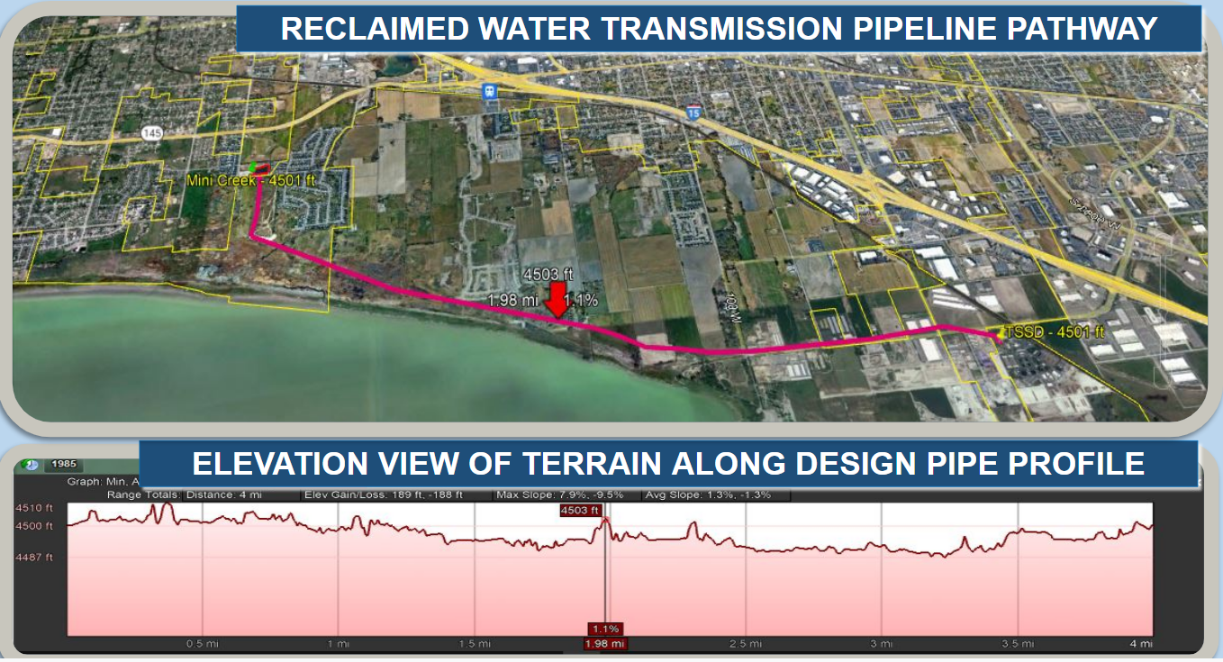
Figure 1: Elevation profile from Google Earth
A more accurate 1 meter DEM was obtained from the UGRC website from the 2016 Great Salt Lake and Utah Lake LiDAR Elevation Dataset. ARCGIS pro was then used to clip and trim this dataset down to the desired area and the elevations as seen in figure 2 were gathered.
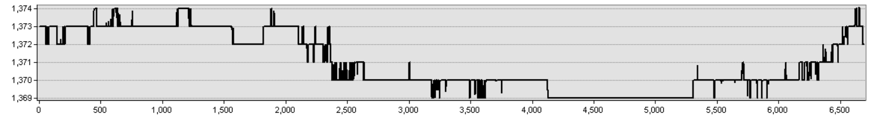
FIgure 2: Elevation Profile from ARCGIS Using 3D Analyst

Easement Data:
Originally it was assumed that the 20 foot TSSD easement around the 60” Sewer line being followed could be breached and that it was only needed to have a vertical clearance. However, in a second meeting with TSSD it was discovered that the entire 20 foot easement must remain clear and that a 5 foot easement outside of this 20 foot easement would need to be obtained by Lehi city before construction. It was assumed that this 5 foot easement would be obtained directly north of the 20 foot TSSD easement and that the line would follow that path all the way to lehi. Once the line was below the pond it was discovered using Utah County Parcel Map that Lehi City owns the property as well as the roadway surrounding the pond as it is shown below in FIgure 3.
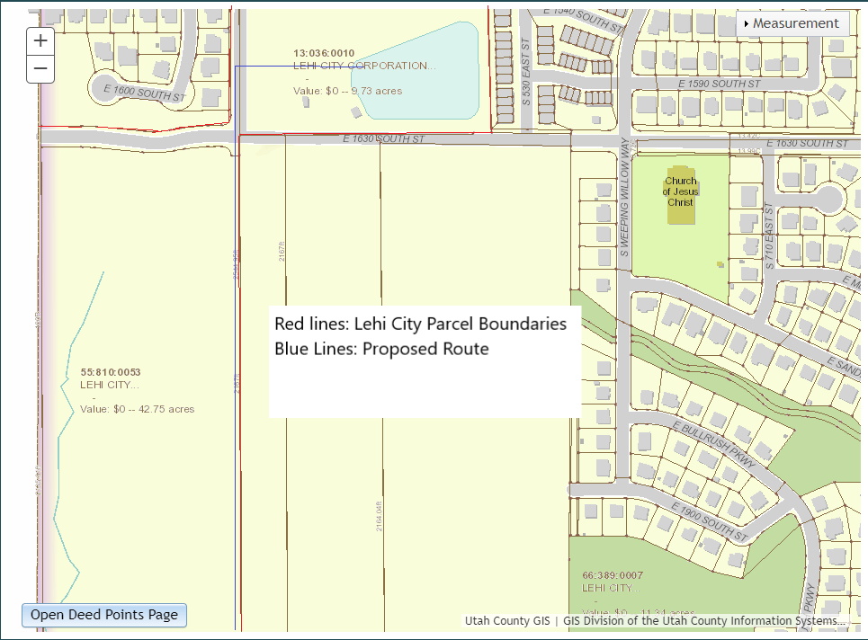
Figure 3: Lehi City Easements and Proposed Pathway
The pathway that follows the 60” TSSD pipeline intercepts this property and the proposed pathway at the bottom of the Lehi City Property. The final proposed pathway is included in the appendix under A2.
Pipe Geometry and Design:
It was decided that the pipeline would be broken into segments based on when the pipe would need to change angles. It was also determined that it would be buried 5 feet underground for current calculations though that can be updated in the design spreadsheet and thus changed with ease. A pipeline profile was then created as shown below in figure 4.
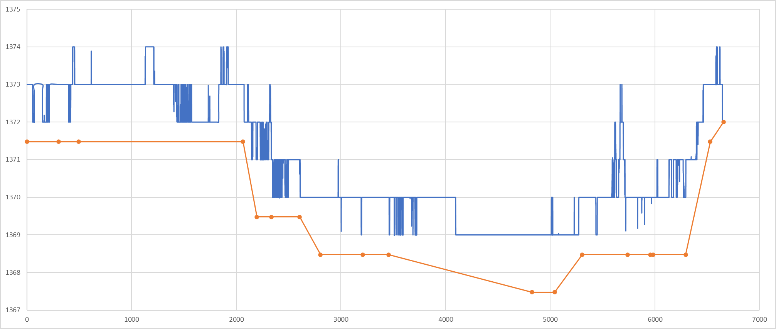
Figure 4: Pipeline profile
Finding the diameter of the pipe was an iterative process that was solved for using the calculation spreadsheet. This spreadsheet solves for the head loss using both the Darcy Wiesbach and Hazen Williams equations. The spreadsheet will be given to the client to use. The inputs required for either of the equations are the same and are length, change in elevation, diameter, flow in MGD (millions of gallons per day), and angle between current and next pipe subtracted from 180. As diameter is required to solve for head loss an iterative process ensues in which the optimal head is found for the best cost. In our case the only cost given by the many pipe companies that were contacted was given for a 48 inch ductile iron pipe and as such this was our optimal pipe for the present. In the future other quotes can be obtained and the diameter changed as is seen fit. The head loss was found to be 0.24 feet and an appropriate pump was selected to meet these requirements recommended by Rhino Pumps. The recommended pump was a vertical centrifugal pump and the head loss requires two of them each taking half of the flow. TSSD informed BYU capstone group 3 that, “For the purposes of this study, please use a location on the west side of TSSD property, towards the middle of the north south line, for the pump station. TSSD has not identified an exact location at this time.” As such for the present this assumption was kept.
Cost Estimate:
The calculation spreadsheet that will be given to the client includes a cost estimate portion that takes as an input the unit cost and the amount needed. Many pump, pipeline, and excavation companies were called during the process of this job in an attempt to obtain cost estimates for this job. Unfortunately even after repeated attempts and many messages left on phones and emails sent very few returned calls or emails were observed. Rhino pumps, which was recommended by Matt Dalton, spoke with the team and were very helpful. They recommended two vertical centrifugal pumps that were about $70,000 a piece for a total of $140,000. A general estimate from an employee of Alder construction was for $800 a foot. After viewing the cost estimates of some other jobs in American Fork area for pipelines it was discovered that this $800 dollar estimate likely includes the cost of excavation and as such excavation was figured into this number. The length of the line is about 21832.7 feet and as such the cost of pipe installation appears to be about $17,466,167.98. These cost estimates can be seen in greater detail in the calculation spreadsheet and are only estimates of the current prices. In the future the rates and amounts can be changed in the spreadsheet to conform with the current market.

Related Issues
Effects of the pipeline on public health:
This water is treated effluent and as such will not be useful for human consumption. It is tertiary water primarily to be used as irrigation water and must be advertised as such to avoid any unfortunate misunderstandings of this point. It will also become much more important that the sewage treatment plant that is discharging this water sets up more water quality testing as certain bacteria or viruses surviving in these conditions could cause widespread problems to those areas that are receiving the discharged water.

Effects of the pipeline on Public Safety:
This pipe when being constructed will involve lots of open trenches as well as oil burning vehicles around sources of water such as the rivers and streams that are in the area. This suggests that many precautions will need to be taken such as traffic control on roads as well as oil spill kits to avoid infiltration into any system that could end in the injury of human beings.

Effects of the pipeline on welfare:
The cost of living right now in Lehi is high and as such this pipeline could bring less expensive water to the public easing at least one of the burdens that most people struggle with which is how to keep their lawns green and still be able to pay their utility bill. This of course has a positive impact on human welfare. Lehi City of course will need to seek funding from somewhere and if that is by some form of tax, though perhaps completely justifiable and economical, will likely not be appreciated by the average taxpayer.

Effects of the pipeline on the geographic population:
This pipeline is intended to take 20 MG/day of treated water from TSSD in Lindon to Lehi city. This water will be secondary and may be used to irrigate fields and water lawns. While the water rights may or may not indicate that Lehi can take this water, the immediate effects would be a lower water level in Utah lake, higher water amount in Lehi City, and more water for sprinklers, and farms. This will allow better growth in farming areas, and cheaper water overall, unless the cost of this project comes from raising taxes. Then the people will see the same cost or higher per gallon of water.

Effects of the pipeline on the surrounding environment:
Currently, this water is being dumped into Utah lake, so this means that the overall volume of Utah Lake will decrease by 73.711 acre-ft per day. This could lead to lower evaporation rates off the surface area of the lake due to a minimally decreased depth which is caused by less direct surface area. During the construction of this pipeline all construction vehicles will need to take precautions when around bodies of water / storm water systems to ensure that a fuel spill does not occur, and that if it does spill kits are on hand.

Effects of the pipeline on the surrounding animal and insect population:
Decreased surface area of the lake could lead to various issues with native species. Currently, effort should be made to look into the possible negative effects that restricting flow to Utah Lake could have upon the fish, frogs, water-skeeters, flies, and other members of the ecosystem. Depending on the habitat of the animals and insects surrounding the lake bed, a decrease or increase could have major consequences. If the specific insect or animal species require a muddy area to live properly, decreasing the level of the lake would increase the total muddy areas, while continuing the flow from TSSD into Utah Lake would keep the muddy areas to a minimum. A major species of concern is the June Sucker, which is limited in number and endemic to Utah Lake and the Provo River. Lowering the water level of the lake slightly could leave less area for the suckers to search for food, while forcing them out into the marginally deeper areas of the lake. As Northern Pike have been spotted inside Utah Lake, any potential change to the spawning areas of the June Sucker and hiding places for the young would need to be considered carefully. While not directly in Utah Lake, the welfare of the animals inhabiting Antelope Island needs to be considered, as the less water flowing into Utah Lake, the lower the flow down the Jordan River into the Great Salt Lake. The lower the water level in the Great Salt Lake, the more salinated the water will become, which could lead to the water becoming too salinated for brine shrimp to survive, or the bison and antelope populations contained on Antelope Island escaping into the surrounding valley. As bison are quite dangerous, containment would need to be initiated, which could lead to injuries or death of the native animal species around and on the lake.

Effects of the pipeline on neighboring populations:
This pipeline would bring more secondary water directly to Lehi City. From Lehi, Saratoga Springs would be able to pull more water according to the water rights currently possessed. The increased use of water could lead to more available primary water for urban exp, which would lead to more primary water being sent to water sanitation plants for recycling while the TSSD secondary water would go to agriculture. Depending on the factors involved, this could be both positive and negative. Additional primary water means that the Central Utah Water Conservancy District may have more primary water to send where needed, or that Lehi could build more residential neighborhoods and complexes, which may alleviate some of the rising costs of living in or near Lehi City as demand currently is quite high with few options.

Effects of pipeline on economic factors:
This tertiary water could reduce the amount of pressure and reliance that members of the Lehi City community have on the city’s primary and secondary water systems. This could reduce the cost of living due to high water prices as well as provide more water for other uses, cosmetic or agricultural. The cost of the project could easily be justified, according to our own calculations, by a simple flat rate cost to run the water each month over time compared to current water costs. Cities cannot properly expand without water, so the more water an area has, generally the better. If the surface area of Utah Lake is negatively affected, this could also provide more incentive to build causeways over Utah Lake and several islands to limit surface area exposure to evaporation. The less surface area on the lake, the less water loss and more water that can be used by the surrounding community. However, due to the current medium to low precipitation period in Utah, every drop counts in Utah Lake, so pulling water at this time or 7 years in the future may not be the best economic decision possible. Studies would need to be performed or examined regarding the effects on the economy due to this project’s potential completion. Increasing the depth of Utah Lake has the positive factor of possible limitation on algae bloom, as well as more water sent down the Jordan River to the Great Salt Lake, which is responsible for a major portion of brine shrimp production and exportation. The less water sent through the Jordan River, the greater the likelihood that the salt content of the Great Salt Lake will increase and become too salinated for the shrimp. As well, decreased flow through the Jordan River would lead to lower water levels around Antelope Island, which could lead to the current wildlife population of the Island escaping and causing property damage to surrounding communities or decrease to the limited bison and antelope populations inhabiting the island.

Lessons Learned

Perhaps the biggest challenges encountered by BYU Capstone team three during the design of this pipeline is communication with clients and stakeholders. This challenge of course is only accentuated by the fact that the members of team 3 are students and this project is far enough out that the current projects of client and stakeholders have much more weight. It was only discovered at the very end that TSSD, for example, wanted a Microsoft Outlook meeting to be set up for formal meetings and a thorough agenda attached so that its members which rely heavily on their outlook calendars to schedule their professional lives could be adequately notified and prepared for those meetings. This is common in the industry right now but is not discussed in BYU undergraduate studies. Phone calls, emails, and in person visits alike were not sufficient in this case. It is important to find how any one organization works in order to know the best form of contact for that organization.

Another challenge of course is communication from within the team itself. There were several times when members of Team 3 misunderstood their particular responsibilities or at times it felt as though all four members would design the pipe a different way. Through weekly team meetings and discussions as well as the help of the faculty here at BYU, such challenges were overcome. In the wake of these communication struggles the importance of a team lead as well as weekly conversations and updates became essential through all of this. Asking the question, “what are my responsibilities this week” became an essential part of each meeting and the last portion of the status update came to contain the names of the team members with each of their responsibilities listed. When feelings were hurt or confusion abounded, it was important for the team to discuss the whys and come up with a solution to move forward. This habit lead to many successes.

Conclusions

From the results of this project BYU capstone group 3 has concluded that the best course of action due to information available is to obtain a five foot easement outside of TSSD’s twenty foot easement containing their 60” sewer line and following the proposed path as shown in the appendix A2. In this five foot easement a 48” ductile iron pipe should be placed at a depth of five feet deep and two vertical centrifugal pumps placed at the given location on TSSD property. However it is also to be concluded that many of these things could change with the changing economy and development of this program by TSSD. Therefore a continued communication should be held with TSSD. Our team has arrived at these conclusions by way of calculating the head loss iteratively by the way of the Darcy Weisbach and Hazen Williams equations, by obtaining accurate elevation data, and by communicating with TSSD as well as Lehi City. The contact of many construction companies has also been included as well as Saratoga Springs.

Recommendations
It is strongly recommended by BYU capstone group 3 that Lehi City perform the following actions:
- Keep in close contact with TSSD and inform them more clearly of the water rights Lehi City has access to as well as locations that Lehi City could place a pump station on TSSD property.
- Reevaluate the validity with current information before making any decisions as to the construction or planning of this project.
- Keep a close eye on the market as far as cost for pumps, pipe, and excavation costs and update the costs when this project is reevaluated.
- Update calculations if a different pipe geometry or path is selected and reevaluate pump size and pipe diameter.
- Follow up with Saratoga springs as to whether or not it would be in their best interests to pipe their flow into Mini Creek Pond as well and if not reevaluate the study with a different flow.

Appendix A
A1 -----------------------------------------------------------------------------------------------------------------------------------20
A2 -----------------------------------------------------------------------------------------------------------------------------------21
Resume Derek Warren --------------------------------------------------------------------------------------------------- 22
Resume Braden Vance ---------------------------------------------------------------------------------------------------23
Resume Cat Calancea --------------------------------------------------------------------------------------------------- 24
Resume Sarah McClellan -----------------------------------------------------------------------------------------------25
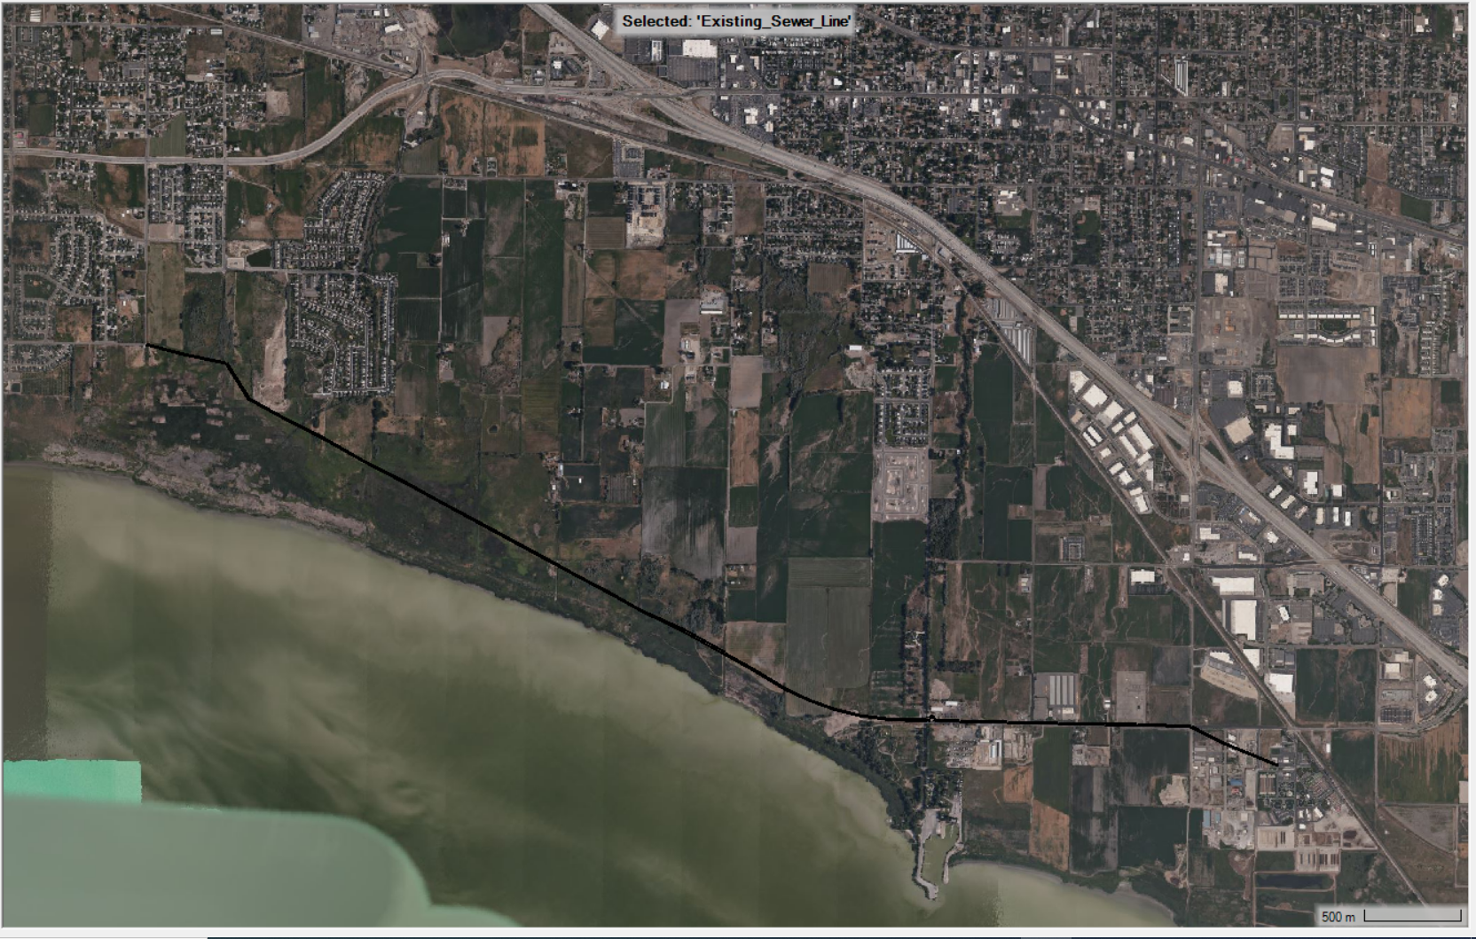
A1: Existing 60” Sewer Line shapefile obtained from TSSD
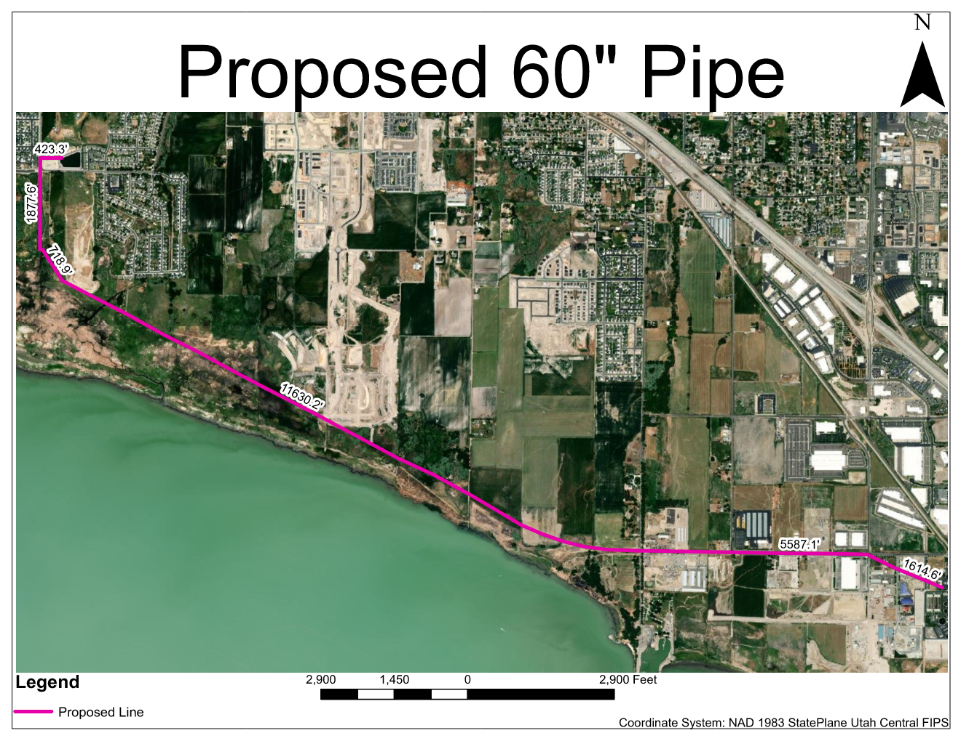
A2: Proposed Pathway
