Room for the river Nijmegen
by Study Abroad-04 | Hail Hydraulics
Brett Durrant
Aaron Stanley
Amelia Hilterbrand
Lucas Toro
A Capstone Statement of Work
submitted to
Daniel P Ames
Brigham Young University
Department of Civil and Construction Engineering
Brigham Young UniverSity
11/27/2023

EXECUTIVE SUMMARY

PROJECT TITLE: ROOM FOR THE RIVER NIJMEGEN

PROJECT ID: CCE_CPST_04

PROJECT SPONSOR: Dan Ames

TEAM NAME: Hail Hydraulics
For a country with an average elevation of four feet below sea level, The Netherlands has needed to master many aspects of water resources engineering just for its citizens to survive. Now, The Netherlands has some of the best civil engineering in the entire world, and many innovations have been designed to hold back sea levels and prevent the relocating of the people of The Netherlands. Despite all this, the country is constantly beset by flooding, both due to seasonal changes and the rising sea levels.
The location of our personal study is along the river Waal, specifically as it passes within the city Nijmegen. Nijmegen is a large city with a higher population density, and as such it becomes very susceptible to flooding when water levels in the river Waal rise. Because of this, local engineers and government campaigned a project known as Room for the River, where land used for residential, commercial, and public means would be repurposed to provide for area for the river to safely flood in an event such as heavy rainfall.
Our requirement as given by Dr. Ames is to analyze the effectiveness of this project by observing and reporting the social, economic, and physical impacts concerning the reclaimed land and the health of the river and surrounding areas. We will also consider other possible alternatives to the Room for the River project, as well as how the effectiveness of these alternatives would compare to the current project. To accomplish these requirements, we will schedule diverse tasks throughout the Fall of 2023, Winter of 2024, and Spring of 2024 to properly research, analyze, and form a conclusion concerning our required study. Such tasks include project identification and initial research, a GIS flood analysis, a final report, and a site visit with a detailed on-site analysis.

Proposed Work Plan
Preliminary Research:
Preliminary research will be primarily focused on the area where the Waal River flows, with particular emphasis on Nijmegen. The research will also include the flood prevention project completed in 2016. The goals of this project will be researched, along with the changes made to the river and surrounding areas.
Flood Analysis:
Flood analysis will be done on the area using GIS to determine the effectiveness of the flood prevention measures. This will be done using an elevation dataset and different water levels on both the pre and post project rivers.
Social Analysis:
Social analysis will be done through research of possible impacts that changing the river could have had on individuals involved. The goal of this will be to discover possible impacts and unintended consequences of the project and will be used in further analyzing the extent to which the goals of the project were fulfilled.
Site Visit:
Site visit will involve travel to the Netherlands to observe the area where the project was completed. This will allow us to make additional observations about the project from a closer perspective.
Exit Criteria:
Exit criteria will include a report delivered to Dr. Ames at the end of capstone.

Schedule
Important Dates/Milestones:
- December 21, 2023 – Complete background research
- March 2, 2024 – Complete GIS flood analysis
- April 13, 2024 – Complete final report
- April 27 – May 14th, 2024 – Site visit
Recurring Events:
- Monthly meeting with Dr. Ames to discuss progress.
- Monday – Team meeting to coordinate our individual work
- Monday – Capstone class

Facilities, Tools, Data and Equipment
Facilities:
-BYU CAEDM Lab- The BYU CAEDM lab supplies BYU students with both computers and access to different programs. We will use it to gain access to ArcGIS Pro
Tools:
-ArcGIS Pro- ArcGIS Pro is a program used for GIS analysis and will be used to analyze flooding in our region of interest
Data:
-Elevation Dataset for area of interest
-Flood height/water level for various severity of flooding

Project Budget
Necessary time:
- Background Research: 4 hours per person
- Team coordination meetings: 0.75 hours per person per week
- Meetings with Dr. Ames: 0.5 hours per person per month
- GIS flood analysis: 3 hours per person
- Final report: 1 hour per person
- Site visit: 15 hours per person
Total Time: 190 hours

Deliverables
Our team plans to produce a final report in Word detailing our initial and on-site research, the data and interpretation of our GIS flood analysis, and our conclusions on the effectiveness of the Room for the River project. Our research and conclusions on possible alternatives to the project will be included within the report. The following deliverables will also be included:
- Short monthly status reports documenting challenges, solutions & progress.
  - Answers to these 4 questions:
    - What challenges have your team encountered in your Capstone project?
    - What actions did your team decided to do to overcome these challenges?
    - Any progress in overcoming these challenges?
    - Is the project on schedule?
- A summary of the progress and current status of our Capstone Project.
- An answer to this question: Did challenges negatively impact the progress of your project? If so, briefly describe the team plan to get back on schedule.
- A poster reflecting a summary of our project to be presented to students, faculty and other interested individuals in the final undergraduate seminar.
- A presentation summarizing our project to be presented to our sponsor.

Performance Standards
Team will provide work for this Capstone project “as is” using best practices and with best effort. Project results cannot be construed as work performed by licensed professionals and cannot be used as “stamped deliverables” without first being reviewed, approved, and stamped by a qualified and relevant licensed professional engineer.

Statement of Qualification
Dr Dan Ames (BYU Faculty): Dr. Ames developed the widely used MapWindow and DotSpatial open source GIS libraries and has been involved in the development of the CUAHSI Hydrologic Information System, HydroShare, HydroDesktop, BASINS, and the Tethys Platform for developing GIS enabled environmental web applications.
Brett Durrant (BYU Team Member): Brett’s experience as a student at BYU and an engineering intern qualifies him to be a member of this team. As an engineering intern, Brett has experience with collaborating in a group in order to understand and solve a technical engineering problem. As a BYU student, Brett has gained a basic understanding of GIS programs.
Amelia Hilterbrand (BYU Team Member): Amelia’s experience having taken GIS and Advanced GIS qualifies her for being a member of this team. Her skillset will particularly aid in the flood analysis portion of the project. Her experience doing a minor in computer science will also aid in the technological side of the project. Additionally, her experience as head TA for statics has helped prepare her to collaborate in a group setting.
Lucas Toro (BYU Team Member): Lucas’s experience having taken a GIS course at BYU as a Civil Engineering Undergrad qualifies him to be a member of this team. From this, Lucas has gained a basic knowledge of GIS software as well as experience in fluid mechanics. Aside from BYU, Lucas has extensive experience with flood analysis and streamflow analysis from working on projects for Sundance Resort while interning at LEI Consulting Engineers. Lucas has also worked as a project lead and at management levels in construction, which has given him effective communication skills and the ability to work within a group to complete a project.
Aaron Stanley (BYU Team Member): Aaron’s experience in construction classes and working construction qualifies him to be a member of this team. His skillset centers in scheduling, safety, management, leadership, framing, electrical work, and estimating. These skills will benefit this group of civil engineers by providing an outsiders perspective in the field of construction. His leadership experience in being the Vice President of the Cougar Marching Band gives him the ability to work well with others, delegate, and lead by example.

Appendix A
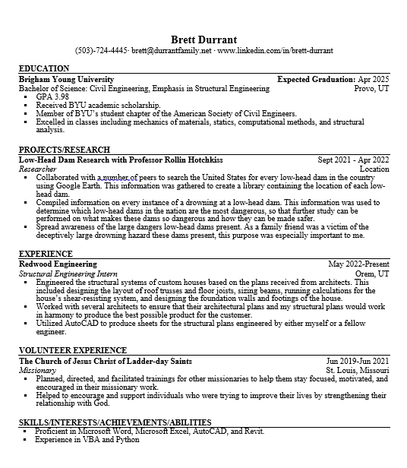
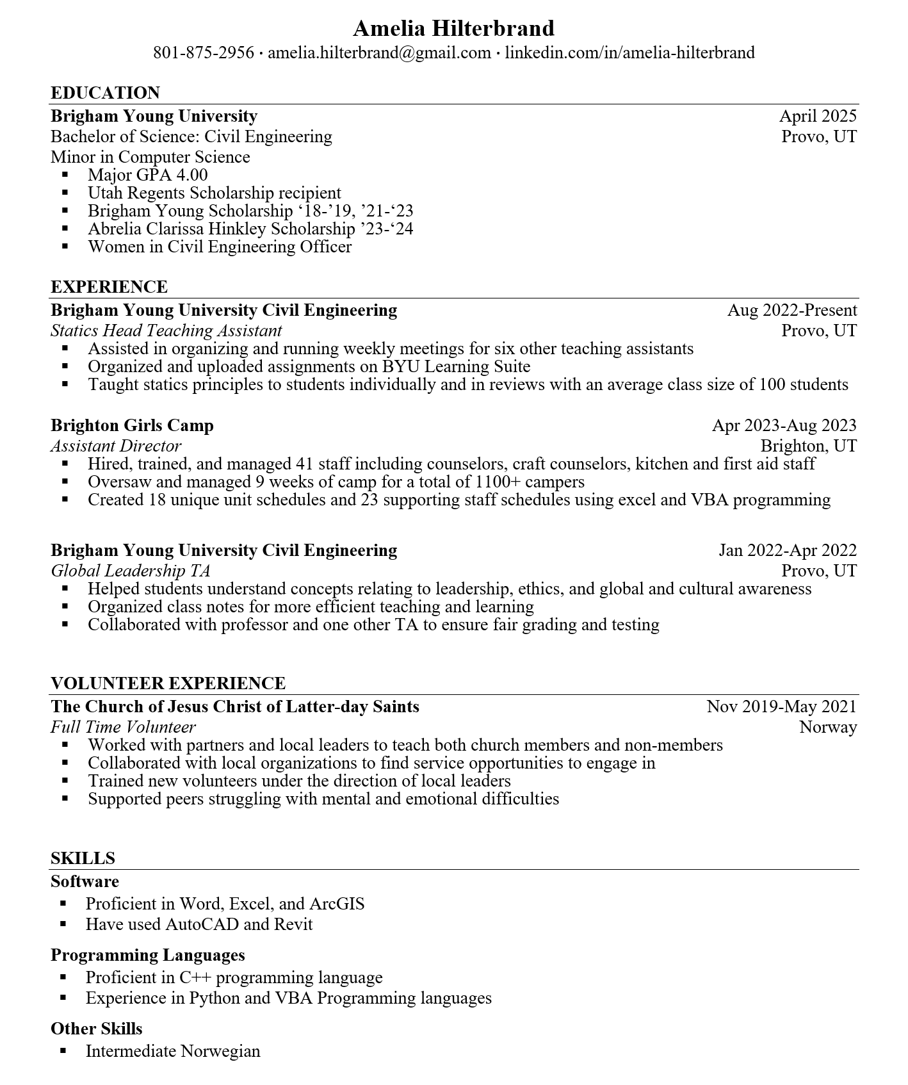
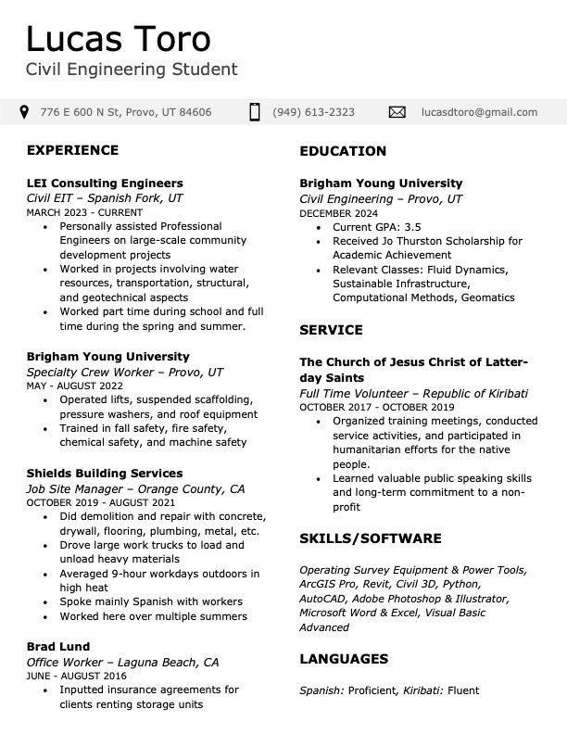
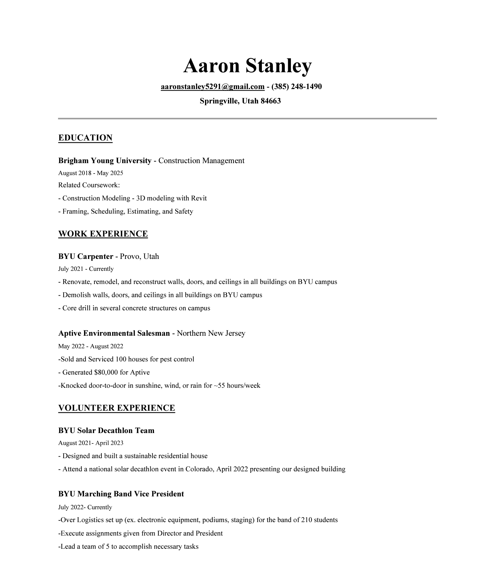

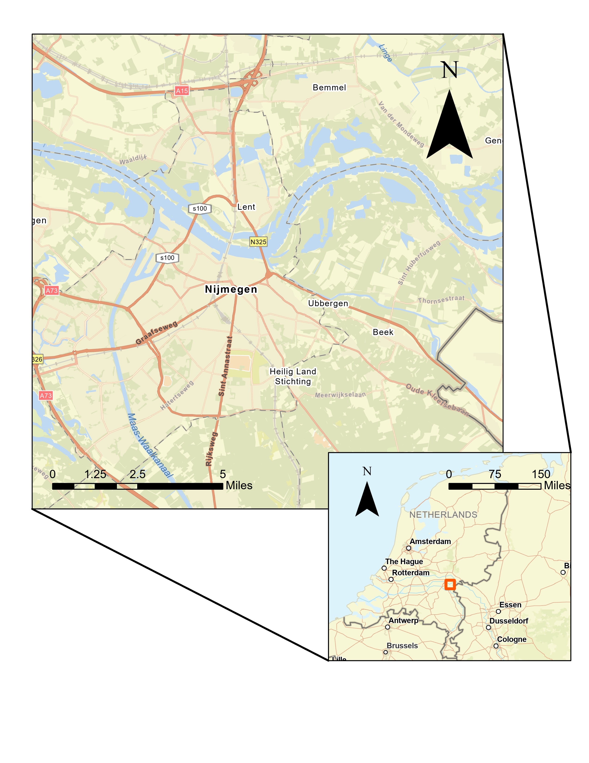
Appendix B- Map of Nijmegen

