HEBER Pedestrian Bridge
by team #9 | Heber pedestrian bridge
nicholas Tholstrom
steven wright
connor hale
hideaki tendo
A Capstone Statement of Work
submitted to
taylor nordquist
agec
Department of Civil and Construction Engineering
Brigham Young UniverSity
11/27/2023

sITE mAP
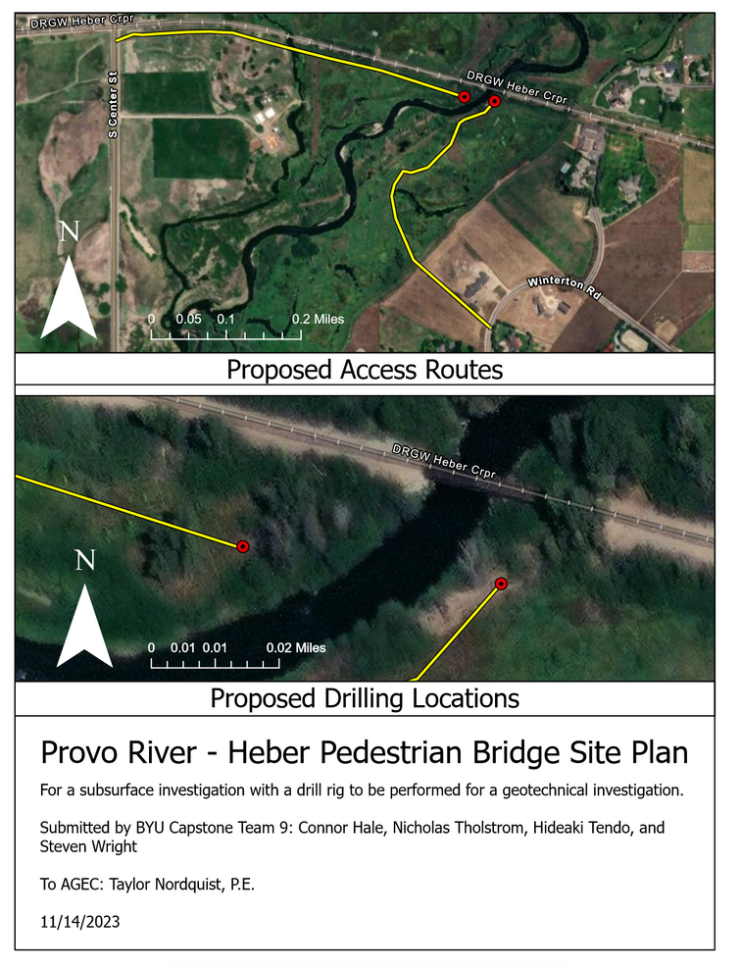

Introduction

PROJECT TITLE: heber pedestrian bridge

PROJECT ID: CCE_CPST_009

PROJECT SPONSOR: AGEC

TEAM NAME: Heber Pedestrian Bridge

The proposed pedestrian path in Heber requires a bridge next to the railroad. A geotechnical investigation is required prior to construction. This team’s project includes the following:
- Prepare investigation site plan.
- Log borings on drill site with drill rig crew.
- Conduct necessary laboratory testing on the site material.
- Summarize lab results.
- Provide recommendations for bridge foundation and abutments.
- Complete all requested assignments and reports for the capstone design class.
This proposal will be submitted on November 27, 2023. Other project specific deadlines will be determined by AGEC. Project reports and assignments will be submitted in accordance with the deadlines established by the BYU capstone organization.

Proposed Work Plan
Prepare investigation site plan:
This will include making a site visit to the Provo River crossing in Heber. Here we will consult with AGEC on the existing site conditions on either side of the river. We will make a map of proposed drilling locations. Also, we will determine a drill rig approach plan to access the drilling locations. We will schedule BYU transportation to carpool to the site.
Log borings on drill site with drill rig crew:
Our team will convene with the drill crew and AGEC at the Provo River crossing to observe and create a drilling log. We will coordinate with AGEC to determine the type of samples to be collected and at what intervals. We will transport the collected samples to the BYU soils lab for further inspection and testing. We will coordinate with the crew if any additional on-site drilling needs to be scheduled.
Conduct laboratory testing on the site material:
The type of material that is found on-site will determine the type of tests that will be performed. Once the correct tests are determined, we will perform them on BYU campus in the soil testing laboratory.
Summarize lab results:
In conjunction with the laboratory testing, we will consult with our project mentor to best summarize the results from the laboratory testing. We will identify the results that will be most useful to providing bridge footing construction recommendations.
Investigate flood plain:
Delineate the extent of 100 year flood plain to determine whether scour calculations at the abutments are required.
Provide recommendations for bridge foundation and abutments:
Based on the results from lab tests, and according to the proposed bridge design by the owner, we will provide the recommendations for the design of the bridge foundations.
Complete all requested assignments and reports for the capstone design class:
This project is mentored by the faculty at BYU. As such, there are certain tasks and schedules that they have defined to ensure that this project is successful. We will submit the solicited assignments by the determined due dates that they have established. This includes, but is not limited to, submitting this report, attending weekly class meetings, creating a final report, presenting findings to our sponsor, and presenting findings to the capstone class.

Schedule
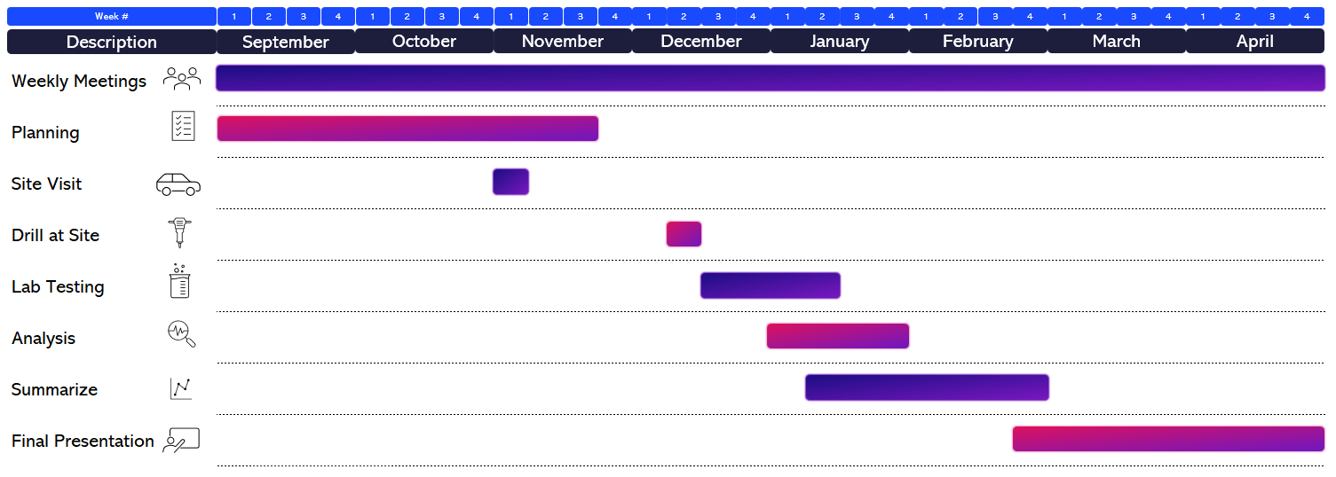

Facilities, Tools, Data and Equipment
The geotechnical investigation will be conducted using the following facilities and equipment:
Track-Mounted Drill Rig:
- Purpose: Perform drilling
- Features: Low ground pressure tracks to minimize soil disturbance. Offers stability and traction in soft soil conditions.
Geotechnical Sampling Tool
- Purpose: Collect representative soil samples for analysis.
- Tools: Buckets and shovels
Personal Protective Equipment (PPE) Rental:
- Purpose: Enhance visibility and protect against head injuries.
- Tools: High-visibility safety vests and hard hats.
4WD BYU Vehicle Rental:
- Purpose: Facilitate traversing marshy areas and challenging terrains. The vehicle also provides space for the buckets of soil samples to be brought back to a lab for analysis.
- Tools: Rental of a 4WD vehicle equipped for off-road conditions.
Standard Penetration Test (SPT)
- Purpose: Evaluate soil resistance and provide N-values for foundation design.
- Tools: SPT drill rig, split-spoon sampler.
- Method: ASTM D1586
Geotechnical Investigation:
- Will be performed in the BYU soils laboratory with ASTM compliant equipment.
Geological Characteristics:
- Geological Surveys: Review existing geological surveys and reports specific to the project location in Utah.
- Soil Maps: Utilize soil maps to identify predominant soil types and their distribution in the region.

Project Budget
We have been given $200 as our budget.
- Dinner/Lunch with Tayler after drilling. Could be before to discuss what tests to perform or after to discuss the implications of the tests. $100.00
- Buckets (8 Buckets x $5/EA) $40.00
- Lids (8x$2 EA) $16.00
- Gallon-sized Ziplock bags $5.00
- Sharpies $5.00
- Presentation Poster (Printed at BYU) $20.00
- Printing Materials $10.00
Total: $200

Deliverables
- Short regular status reports:
  - Completed weekly at Monday team meetings.
  - Answers 4 questions:
    - What challenges have we encountered?
    - What actions did we decide to overcome these challenges?
    - Any progress in overcoming challenges?
    - Is the project on schedule?
- Final report
  - Will provide a comprehensive report on project outcomes.
- Final poster
  - Will summarize project outcomes for presentation purposes.
- Final presentation
  - Will present project outcomes to sponsor.

Performance Standards
All soils testing will follow ASTM and AASHTO standards. Team will provide work for this Capstone project “as is” using best practices and with best effort. Project results cannot be construed as work performed by licensed professionals and cannot be used as “stamped deliverables” without first being reviewed, approved, and stamped by a qualified and relevant licensed professional engineer.

Statement of Qualification
Kyle Rollins – Project Mentor
Kyle Rollins received his BS degree from Brigham Young University and his Ph.D. in Civil Engineering from the University of California at Berkeley. After working as a geotechnical consultant, he joined the Civil Engineering faculty at BYU in 1987 following after his father who was previously a geotechnical professor. His research has involved geotechnical earthquake engineering, deep foundation behavior, bridge abutments, collapsible soils, and soil improvement techniques. He has published over 190 technical papers and supervised over 130 graduate students. He was recognized as the engineering educator of the year by the Utah State Engineers Council and received a Governor's Award for Science and Technology in 2017. ASCE has recognized his work with the Huber research award, the Wellington prize, and the Wallace Hayward Baker Award. In 2009, he was the Cross-Canada Geotechnical lecturer for the Canadian Geotechnical Society and in 2013 he received the Jorj Osterberg Award for innovation in foundation testing from the Deep Foundation Institute. Source

Rollin Hotchkiss – Capstone Course Facilitator
Dr. Hotchkiss joined BYU in 2005 after having worked at the University of Nebraska-Lincoln and Washington State University. He graduated from BYU with a B.S. in Civil Engineering and completed an M.S. in Civil Engineering at Utah State University. After working for six years for the Tennessee Valley Authority, Rollin attended the University of Minnesota where he earned his Ph.D. He is a registered professional engineer and holds a Diplomate in the American Academy of Water resources Engineering. He and his wife, parents of four children, live in Springville, Utah. Source
Harold Mitchell – Capstone Course Facilitator
State of Utah, Professional Land Surveyor (2001 - Present), State of Utah, Professional Engineer (1996 - Present). Source

Appendix A
