DETERMINING PAVEMENT DELAMINATION VIA THERMOGRAPHY
PROJECT ID: CEEN_CPST_011

by

Thermal Precision Drones

Spencer Moon
Samuel Cuessy
Beau Switzer
Blake Hull

A Capstone Project Report

Submitted to

Gustavious Williams
Department of Civil and Construction Engineering
Brigham Young University
April 8, 2024

Executive Summary

PROJECT TITLE: ​Determining pavement delamination ViA THERMOGRAPHY
PROJECT ID: CEEn_CPST_011
PROJECT SPONSOR: Dr. Gustavious Williams
TEAM NAME: Thermal Precision Drones

The main objective of the experimental project was to determine if pavement delamination can be detected via thermography. Bridge Delamination is when corrosion occurs in the embedded rebar in the bridge deck. When corrosion occurs, it causes the rebar to expand. This expansion of the rebar causes cracking within the concrete to occur which can eventually lead to potholes when the cracks reach the surface. It has been found that these delaminated areas heat up and cool down quicker than the rest of the bridge deck, hence is why we are trying to detect delamination via thermography.
To analyze the thermography of the bridge thermal images were retrieved. The thermal images were retrieved using a drone that had a thermal camera attached. The images were uploaded to AutoCAD where the images were scaled, and the delaminated areas were predicted using hatching. Our predictions were compared to the High-Speed Acoustic Impact test that was performed on the same bridge back on July 13th, 2020. The High-Speed test is an established effective test to detect bridge delamination. Using these results to compare the project we were able to make a conclusion that thermography is a viable way of measuring pavement delamination in bridge decks.
Our findings align closely with existing research, particularly studies by Hendricks et al. (2020) and Sultan and Washer (2018), further reinforcing the reliability of thermography for delamination detection. Despite challenges such as curved image composites, our iterative approach and advanced software tools like AutoCAD and Civil 3D ensured precision in quantifying delaminated areas.
The project, initiated on November 11, 2023, aimed to reach a consensus on the efficacy of thermography in detecting pavement delamination and to develop a standardized algorithm for future use. By April 13, 2023, we achieved our objectives, providing valuable insights into infrastructure health monitoring and paving the way for enhanced maintenance strategies.

Table of Contents
Contents
Executive Summary 2
List of Figures 4
Introduction 5
Schedule 9
Assumptions & Limitations 10
Design, Analysis & Results 10
Related Issues 18
Lessons Learned 19
Conclusions 19
Recommendations 20
Appendix A 21

List of Figures

Fig. 1 High-speed acoustic impact-echo sounding trailer with labeled components (Hendricks, et al., 2020).

Fig. 2. Overview of the high-speed acoustic impact-echo sounding approach. A Chain links around a tire are used to repeatedly impact the concrete bridge deck, generating an acoustic response. B Thick, circumferential chains are employed to mechanically excite the bridge deck, while directional microphones record the acoustic responses of the repeated impacts. C The complete high-speed acoustic impact-echo bridge deck scanning apparatus includes six chained tires and recording microphones. D 1-second spectral density (sd) spectrogram of audio recorded during the process shows spikes of acoustic energy, approximately 20 to 30 dB louder than normal chain noises and traffic, indicating the presence of delamination labeled on the spectrogram (Hendricks et al., 2020).

Fig. 3. Unsuccessful Composite Images

Fig. 4. Custom pseudo color style applied to thermal imagery, highlighting areas of the bridge with above-average temperatures in bright tones and below-average temperatures in dark tones.
Fig. 5. Latitude and longitude coordinates of specific reference stations on the Google Earth Pro image used for spatial alignment.
Fig. 6. Predicted delamination using a conservative hatching approach with AutoCAD Civil 3D and Google Earth Pro integration.
Fig. 7. Sound Detection Results
Note: a) The bridge deck areas for the training and testing datasets, with delaminated areas identified from the manual chain-drag survey, are denoted by blue markings. b) Detection results obtained at a speed of 25 km/h, depicting the estimated scanning paths represented by green lines. Delaminated areas identified from the manual chain-drag survey are marked in blue, while delaminated areas estimated from high-speed acoustic impact-echo testing are marked in red. c) Detection results achieved at a speed of 35 km/h, utilizing the same color scheme as in part b. d) Detection results obtained at a speed of 45 km/h, following the color scheme used in part b. e) Detection results for variable-speed passes, with the same color scheme as in part b, showcasing the estimated scanning paths and delaminated areas identified from both manual chain-drag survey and high-speed acoustic impact-echo testing. (Hendricks et al., 2020)

Fig. 8. Predicted delamination using a liberal hatching method.

Introduction

Delamination in bridge decks and road pavements is a pervasive issue that significantly compromises the integrity and safety of transportation infrastructure. This phenomenon typically occurs when the bond between layers of material, such as concrete and reinforcing steel, breaks down. Factors contributing to delamination include moisture intrusion, freeze-thaw cycles, corrosion of reinforcement, and the constant stress of vehicular loads. The resulting separation and voids within the structure can lead to accelerated deterioration, reduced load-carrying capacity, and ultimately, the failure of critical components. Recognizing the potential hazards, including increased risk of accidents and costly emergency repairs, timely detection and maintenance are paramount.

Traditional methods for detecting delamination, such as chain dragging and hammer sounding, rely on acoustic cues to identify compromised areas. These techniques, while effective to a degree, are labor-intensive, subjective, and often require partial or full closure of roadways, leading to logistical challenges and public inconvenience. Moreover, their accuracy can be limited, especially in complex or noisy environments as shown in Fig. 1.

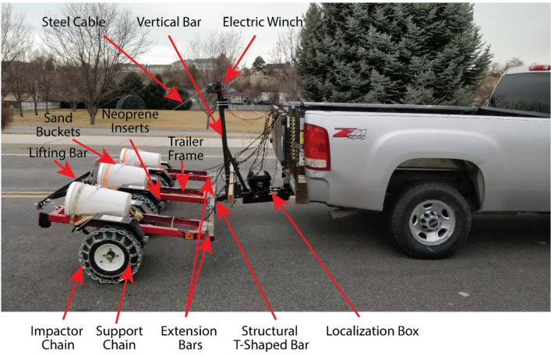
Fig. 1 High-speed acoustic impact-echo sounding trailer with labeled components (Hendricks, et al., 2020)

This project proposes an innovative approach to assessing pavement delamination, particularly in bridge decks, by exploiting the thermal conductivity properties of delaminated areas. The underlying theory is that heat transfers more rapidly through delaminated sections compared to intact ones, due to the presence of air gaps that alter thermal resistance. We hypothesize that a drone equipped with thermographic imaging technology can swiftly and accurately map these variations in thermal conductivity, offering a non-invasive, efficient alternative to traditional methods.

Our thermographic method of determining bridge delamination will be compared to the High-Speed Acoustic Impact Test conducted on the same bridge on July 13th, 2020. The High-Speed Acoustic Impact testing involves a sophisticated chain dragging test, where a trailer with chained wheels is dragged across the bridge surface. The trailer is equipped with 6 wheels, each with chains wrapped around them, and three sand buckets on top of every two wheels to ensure high-quality impacts, see Fig. 1.

The chains on the trailer create impact noise upon contact with the bridge surface. To isolate these impacts, Neoprene pads are placed above the wheels. Microphones are strategically positioned to capture these impact noises, and the data collected is processed by a computer. The computer analyzes the sound to determine if there's a hollow quality, which indicates delamination in the bridge structure, as shown in Fig. 2. This method has been approved as a reliable means of assessing structural integrity and will serve as a benchmark against which our thermographic data will be compared.

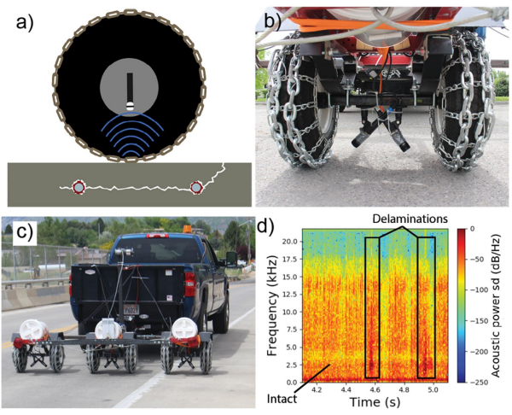
Fig. 2. Overview of the high-speed acoustic impact-echo sounding approach. a) Chain links around a tire are used to repeatedly impact the concrete bridge deck, generating an acoustic response. b) Thick, circumferential chains are employed to mechanically excite the bridge deck, while directional microphones record the acoustic responses of the repeated impacts. c) The complete high-speed acoustic impact-echo bridge deck scanning apparatus includes six chained tires and recording microphones. d) 1-second spectral density (sd) spectrogram of audio recorded during the process shows spikes of acoustic energy, approximately 20 to 30 dB louder than normal chain noises and traffic, indicating the presence of delamination labeled on the spectrogram (Hendricks et al., 2020).

The practical application of this method involves deploying a drone to capture thermal images of the bridge deck, with the expectation that the thermographic data will reveal hotspots indicative of delamination. The success of this approach hinges on the ability to obtain clear, accurate thermal images that can be precisely correlated with physical locations on the bridge deck. This would validate thermography for delamination detection and demonstrate its advantages in speed, safety, and minimal disruption to traffic.

However, the implementation of this innovative method is not without its challenges and assumptions. One significant hurdle encountered early in the project was a lack of clear guidance, as the initial proposal was put forward by a professor who was subsequently unavailable to provide detailed direction, leaving the team to navigate the project's intricacies largely independently. This "walking in the dark" phase introduced uncertainties and necessitated a flexible, exploratory approach to developing and refining the methodology.

Furthermore, the project was predicated on the assumption that the analysis of thermal images would yield straightforward, linear composites that could be easily mapped to specific areas of the bridge deck. Contrary to this expectation, the processing of the collected data often resulted in curved image composites, complicating the interpretation and correlation of thermal anomalies with physical locations of delamination as shown in Fig. 3. This discrepancy highlighted the complexity of the task and the need for advanced analytical techniques to accurately interpret the thermographic data.

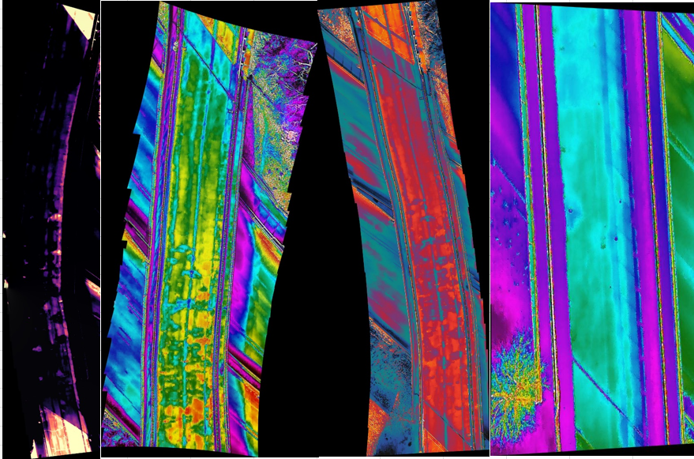
Fig. 3. Unsuccessful Composite Images

In conclusion, this project represents a promising step forward in the ongoing effort to enhance the safety and longevity of our transportation infrastructure through innovative monitoring techniques. By exploring the potential of drone-based thermography for detecting delamination in bridge decks, we aim to provide municipal governments, departments of transportation, and maintenance agencies with a valuable tool that could revolutionize the way infrastructure inspections and repairs are conducted. Despite the challenges and learning curves encountered, the insights gained from this endeavor could pave the way for more efficient, effective, and proactive maintenance strategies, ensuring the safety and reliability of critical transport routes.

For this project, our tasks are to collect data, analyze it on a computer program, and determine if the data is accurate compared to the known data we have. We will present our findings in a report given to our sponsor, Gustavious Williams, for evaluation. Weekly status reports will be given to our sponsor in addition to the final report. Additionally, we will meet monthly with our sponsor for feedback. Our deliverables- including our report- will be turned in by April 13, 2024.

Schedule

Task Number | Task Description | Due Date | Check Off Box
1 | Statement of Work | 11/27/2023 | x
2 | Weekly Team Meeting | 11/27/2023 | x
3 | Monthly Sponsor Meeting | 12/1/2/23 | x
4 | Weekly Team Meeting | 12/4/2023 | x
5 | Weekly Team Meeting | 12/11/2023 | x
6 | Weekly Team Meeting | 1/8/2023 | x
7 | Monthly Sponsor Meeting | 1/12/2023 | x
8 | Weekly Team Meeting | 1/15/2023 | x
9 | Weekly Team Meeting | 1/22/2023 | x
10 | Weekly Team Meeting | 1/29/2023 | x
11 | Monthly Sponsor Meeting | 2/2/2023 | x
12 | Weekly Team Meeting | 2/5/2023 | x
13 | Weekly Team Meeting | 2/12/2023 | x
14 | Drone AM Data Collection | 2/17/2023 | x
15 | Weekly Team Meeting | 2/19/2023 | x
16 | Weekly Team Meeting | 2/26/2023 | x
17 | Meeting with Dr. Mitchell | 3/1/2023 | x
18 | Drone PM Data Collection | 3/2/2023 | x
19 | Weekly Team Meeting | 3/4/2023 | x
20 | Weekly Team Meeting | 3/11/2023 | x
21 | Form Analysis from Data (does it work?) | 3/16/2023 | x
22 | Weekly Team Meeting | 3/18/2023 | x
23 | Weekly Team Meeting | 3/25/2023 | x
24 | Rough Draft of Final Report of Findings | 3/29/2023 | x
25 | Weekly Team Meeting | 4/1/2023 | x
26 | Turn in Poster | 4/3/2023 | x
27 | Weekly Team Meeting | 4/8/2023 | x
28 | Final Draft of Final Report of Findings | 4/13/2023 | x
29 | Final Poster and Presentation | 4/13/2023 | x

Assumptions & Limitations

The project operated under several assumptions and faced limitations that impacted its methodology and outcomes. Initially, there was a dependency on sunlight for drone flights to minimize shadows, but this was addressed by implementing cloudy flight missions. However, a limitation arose concerning automated hotspot detection, as the project assumed the availability of a program for this task. Instead, hotspot identification relied on manual observation using visual cues due to the absence of a suitable program.

Additionally, while the project aimed to identify hotspots, there was limited analysis conducted to quantify temperature differences between these hotspots and the surrounding road, which could have provided valuable insights into delamination severity. Another limitation was the absence of nighttime assessments to determine whether delaminated spots were cooler than the rest of the road.

Incorporating nighttime data collection could have provided a more comprehensive understanding of thermal differentials throughout the day. Furthermore, challenges were encountered in processing thermal data to produce accurate mappings of delaminated areas, highlighting the need for advanced analytical techniques. ￼

Design, Analysis & Results

In the design and analysis phase of our project, we focused on optimizing the data acquisition process using a drone equipped with a camera set on a gimbal. The drone was programmed to execute several flight missions over the bridge, capturing images at precise intervals to ensure comprehensive coverage of the area under study. Initially, the camera gimbal was fixed at a 90-degree angle, allowing for vertical shots directly downward, covering the length of the bridge.
To accommodate varying environmental conditions, we designed flight missions under different weather scenarios, including sunny and cloudy conditions, at altitudes of 45 and 55 feet. This approach was intended to mitigate the impact of sunlight and cloud cover on the thermal imaging process. The drone’s flight path was systematically planned from the south end of the bridge to the north, ensuring a methodical coverage area. Image overlap was carefully considered, with a 90% overlap rate chosen to maximize the continuity and detail in the resulting composite, whereas a 10% overlap would lead to almost no redundancy in the captured images.
After the flight missions, the captured images were stored on an SD card, which was then used to transfer the files to a computer for analysis. We employed various software tools for image processing, notably the Microsoft Image Composite Editor (ICE). This software enabled us to import the JPEG images and generate composite images from the selected files. Despite the theoretical simplicity of this process, we encountered challenges in creating accurate composite images. Many of the stitched images resulted in curved representations, deviating from the actual linear structure of the bridge. This discrepancy led to difficulties in achieving a true-to-life composite image of the bridge, with some composites appearing distorted, either curving or inconsistently incorporating the individual images, leading to what could be described as sloppy outcomes.
Composite Images
Orthomosaics, also known as orthophotos, are detailed, accurate, and geometrically corrected aerial or satellite images. They are created by stitching together multiple overlapping photographs of the same area, taken from different angles, into a single, seamless image. The process of creating orthomosaics involves rectifying the images to remove distortions caused by the camera's perspective and terrain variations, resulting in a map-like image with uniform scale throughout.
Creating orthomosaics from thermal images proved harder than we had anticipated. Our programs had issues interpreting thermal pseudo color images and products from these programs were very unsatisfactory. After extensive experimentation with different programs, we came up with the following workflow.
After capturing thermal gridded flight images and data, we stored them in Box in a shared folder. From the shared folder, we uploaded a couple of thermal images into the Autel IR PC Tool computer program and used its functions to find the average temperature of the bridge for that particular flight.
With the average temperature of the bridge in mind, we opened QGIS and added all the tiff files for that flight. Using one of the files, we made a custom pseudo color style using the average bridge temperature. Areas of the bridge that were above average were made very bright while areas that were below average were made very dark, as seen in Fig. 4. This style was applied to all the tiff files in the gridded flight. Then, each tiff file was exported as a rendered image.
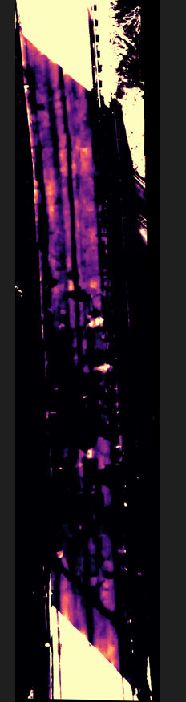
Fig. 4. Custom pseudo color style applied to thermal imagery, highlighting areas of the bridge with above-average temperatures in bright tones and below-average temperatures in dark tones
Each rendered image was uploaded to Image Composite Editor (ICE). In ICE, we set the size of the gridded flight, the overlap percent, and the camera movement type and had the program create an orthomosaic of our images. We repeated these steps for every flight. Even though the bridge looks curved in some orthomosaics, we believe they do an adequate job of demonstrating the locations of the warmer spots of the bridge.
AutoCAD Analysis
To accurately analyze the thermal images captured by our drone, we first needed to integrate these images with a detailed base map. We utilized Google Earth Pro to obtain a high-resolution image of the bridge area, pinpointing specific locations on the bridge deck to serve as reference points for alignment. The coordinates of these locations, referred to as "stations," were meticulously recorded. For instance, Station 1 was at latitude 40°15'56.22"N and longitude 111°40'17.63"W, and Station 2 at latitude 40°15'58.84"N and longitude 111°40'17.16"W. These stations provided the necessary spatial reference to accurately overlay our thermal images onto the bridge's geographic location, shown in Fig. 5.
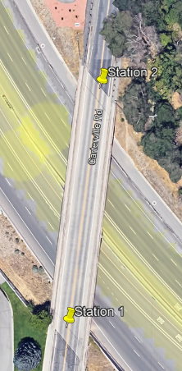
Fig. 5. Latitude and longitude coordinates of specific reference stations on the Google Earth Pro image used for spatial alignment
In AutoCAD Civil 3D, we imported the Google Earth image and then used the 'Point' command to add markers at the stations, entering the latitude and longitude coordinates directly. Aligning the thermal images with these points required careful manipulation; we adjusted the images' orientation and scale to match the real-world dimensions of the bridge deck. For example, we ensured that 267 AutoCAD units corresponded to one foot, establishing a consistent scale for analysis.
The process of "hatching" in Civil 3D involved using the 'Hatch' command to fill specific areas within the thermal images with patterns or solid fills, which helps in visualizing and differentiating the various sections of the bridge deck, particularly the areas suspected of delamination. By applying a dash hatch pattern with a scale of 50, we delineated the areas of concern. The 'Match' command was then used to apply the same hatch pattern to similar areas across the image, ensuring consistency in our visual analysis.
After aligning and hatching, we examined the hatched areas to assess the extent of delamination. The hatch patterns helped to visually represent the delaminated areas, making it easier to estimate their size and distribution across the bridge deck. This method provided a clear, detailed view of the bridge’s condition, allowing for precise identification of areas where delamination had occurred.
By integrating Google Earth Pro imagery with AutoCAD Civil 3D, and employing techniques like precise coordinate mapping, image alignment, and hatching, we could accurately overlay and analyze the thermal images against the actual bridge layout. This approach facilitated a detailed examination of the bridge deck's condition, enabling us to identify and quantify areas affected by delamination effectively, as shown in Fig. 6.
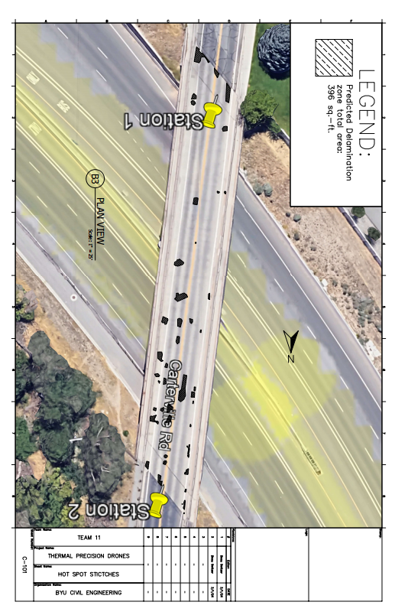
Fig. 6. Predicted delamination using a conservative hatching approach with AutoCAD Civil 3D and Google Earth Pro integration

Results
Our analysis of the results reveals a close alignment between our findings and those presented in the Hendricks et al., article, see Fig. 7.
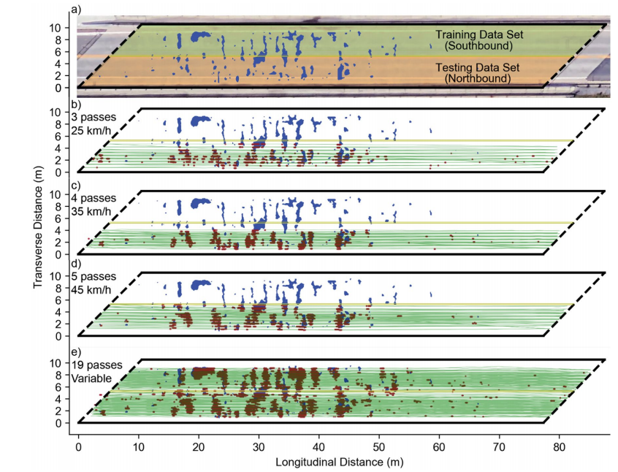
Fig. 7. Sound Detection Results
Note: a) The bridge deck areas for the training and testing datasets, with delaminated areas identified from the manual chain-drag survey, are denoted by blue markings. b) Detection results obtained at a speed of 25 km/h, depicting the estimated scanning paths represented by green lines. Delaminated areas identified from the manual chain-drag survey are marked in blue, while delaminated areas estimated from high-speed acoustic impact-echo testing are marked in red. c) Detection results achieved at a speed of 35 km/h, utilizing the same color scheme as in part b. d) Detection results obtained at a speed of 45 km/h, following the color scheme used in part b. e) Detection results for variable-speed passes, with the same color scheme as in part b, showcasing the estimated scanning paths and delaminated areas identified from both manual chain-drag survey and high-speed acoustic impact-echo testing. (Hendricks et al., 2020)

Figures 6 and 7a showcase a clear correlation between the thermal drone imagery and the detected delamination, indicating the effectiveness of our detection methods. By visually comparing the spots identified in our thermal drone imagery with those in Figure 7a, it becomes evident that our approach yielded accurate results in detecting delaminated areas on the bridge deck.

Utilizing the hatching tools in AutoCAD, we further quantified the extent of delaminated areas. Adopting a conservative approach, our calculations indicated a delaminated area of 396 square feet, which corresponds well with the conservative estimates depicted in Figure 7a of the article. Similarly, employing a liberal approach, as illustrated in Fig. 8., our analysis revealed a delaminated area of 1193 square feet, aligning closely with the liberal estimates presented in the referenced figure.
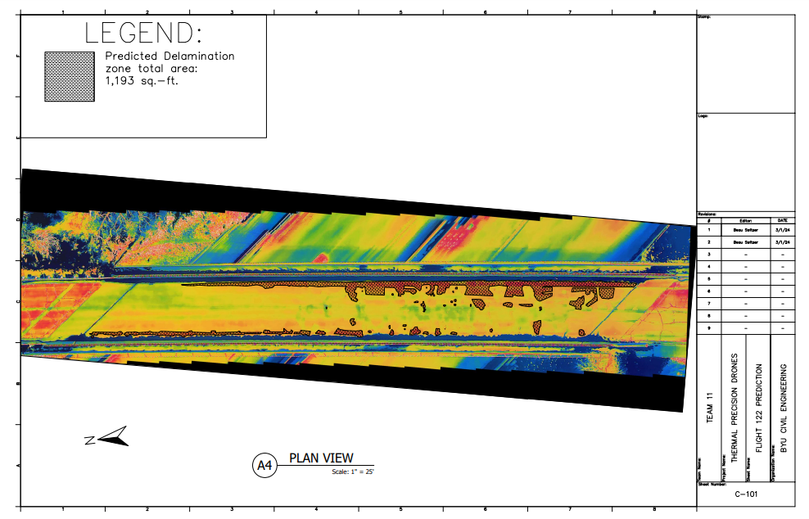
Fig. 8. Predicted delamination using a liberal hatching method

These results highlight the reliability and precision of our detection methodology, showcasing a consistent and accurate assessment of delaminated areas on the bridge deck. The close agreement between our findings and the data provided in the article further validates the efficacy of our approach in detecting and quantifying delamination, essential for informed decision-making regarding maintenance and repair strategies for bridge infrastructure. ￼

Related Issues

Our project has several significant impacts on the public. Firstly, it addresses safety concerns associated with unstable bridge decks by conducting rapid surveys to identify areas requiring repair. This proactive approach ensures the quick safeguarding of public safety. Economically, our method proves to be cost-effective as drone flights can be completed in minutes without the need for bridge closures, thereby avoiding disruptions to travel and commerce.
Regarding public health, our project contributes by enhancing the safety of transportation infrastructure. Through the quick identification and repair of delamination areas on bridge decks, the risk of accidents and injuries to motorists and pedestrians is reduced, creating a safer environment for all bridge users.
Safety is the primary impact of our project. By promptly detecting and addressing delamination issues, we mitigate the risk of structural failures and accidents on bridges, thus enhancing the overall safety of transportation infrastructure and ensuring the well-being of the public.
In terms of welfare, our project positively impacts the community by maintaining reliable and safe transportation routes. Preventing potential bridge failures due to delamination minimizes disruptions to travel and commerce, leading to smoother daily routines for individuals and businesses.
Economically, our project has significant implications. By employing drone-based inspections, costs associated with traditional methods such as road closures and labor-intensive surveys are reduced. This efficiency results in cost savings for government agencies and taxpayers, while also minimizing disruptions to commerce and transportation activities.
On a global scale, while our project's direct impact may be localized, it sets a precedent for the adoption of innovative technologies and proactive maintenance strategies. By showcasing the effectiveness of drone-based inspections for infrastructure maintenance, we contribute to global best practices in ensuring the safety and longevity of transportation networks.
In summary, our project has multifaceted impacts, ranging from enhancing public safety and welfare to promoting economic efficiency and environmental sustainability. Through proactive measures and innovative technologies, we contribute to creating a safer, more resilient, and sustainable transportation infrastructure system.

Lessons Learned

We learned that coordinating meetings with sponsors can be challenging due to everyone's busy schedules. It's crucial to proactively reach out to sponsors, maintain open lines of communication, and prioritize meetings to ensure progress on the project. Flexibility and understanding of each other's commitments are also essential in navigating scheduling conflicts effectively.
Our project highlighted the significance of having a diverse skill set within the team. For instance, having team members with expertise in software tools like AutoCAD and other computer skills proved invaluable for data analysis and processing. It's essential to leverage the strengths of each team member to ensure comprehensive project completion.
Working effectively with team members requires patience and trust. It's important to trust that team members will complete their assigned tasks diligently and on time. Building a collaborative environment based on trust fosters better communication, teamwork, and overall project success.

Conclusions
Our project focused on determining pavement delamination via thermography, and our findings reveal the effectiveness of this method in accurately measuring delamination on bridge decks. By analyzing thermal drone imagery and aligning it with known data, we successfully detected and quantified delaminated areas. Our results closely align with existing research, particularly studies conducted by Hendricks et al. (2020) and Sultan and Washer (2018), reinforcing the reliability and validity of drone-based thermography for delamination detection. Utilizing advanced software tools like AutoCAD and Civil 3D, we quantified delaminated areas with precision, highlighting the robustness of our methodology. However, our project encountered challenges such as curved image composites, which required iterative experimentation and customized workflows for resolution.
Despite these challenges, our project underscores the potential of thermography as a non-invasive and efficient approach to monitoring infrastructure health and safety. These findings contribute valuable insights into transportation infrastructure conservation and pave the way for further advancements in maintenance strategies.

Recommendations

One of our potential deliverables was a published journal article if our findings were conclusive enough to be published. If our sponsor finds that our results are not quite ready for publication, we recommend that further study be done. Specifically, our biggest technical challenge was uploading and hatching the images for analysis, so if a better process can be discovered, that would be a significant improvement. If real work crews were to use thermography to measure delamination, an efficient uploading and hatching process would allow them to report the results to coworkers and clients in a timelier manner. We do not think that a capstone team should do this, as the scope of this improvement isn’t large enough for a capstone project, but some students working as research assistants would suffice for this. Again, this recommendation is contingent on the determination that our results are not ready for publication.

Appendix A

Hendricks, L.J., Baxter, J.S., Chou, Y. et al. High-Speed Acoustic Impact-Echo Sounding of Concrete Bridge Decks. J Nondestruct Eval 39, 58 (2020). https://doi.org/10.1007/s10921-020-00695-0
Sultan, Ali A., and Glenn A. Washer. “Reliability analysis of ground-penetrating radar for the detection of Subsurface Delamination.” Journal of Bridge Engineering, vol. 23, no. 2, Feb. 2018, https://doi.org/10.1061/(asce)be.1943-5592.0001182.

