HEBER PEDESTRIAN BRIDGE
Project ID: CEEn_CPST_09

by

Team #9
Nicholas Tholstrom
Hideaki Tendo
Steven Wright
Connor Hale

A Capstone Project Final Report

Submitted to

Tayler Norquist
AGEC

Department of Civil and Construction Engineering
Brigham Young University

April 17, 2024

Executive Summary

PROJECT TITLE: ￼ HEBER PEDESTRIAN BRIdge
PROJECT ID: CEEn_CPST_09
PROJECT SPONSOR: AGEC
TEAM NAME: Team 9

A pedestrian path is currently being designed by the Utah Department of Transportation (UDOT) in Heber, UT. The path is routed to cross two rivers with pedestrian bridges. Applied Geotechnical Engineering Consultants, Inc. (AGEC) was contracted to perform a geotechnical analysis at both bridge locations. Brigham Young University (BYU) Civil Engineering Capstone Team 9 was sponsored by AGEC to complete soil testing and make footing design recommendations for the pedestrian bridge at the Provo River crossing. This was completed by the team with assistance from Taylor Norquist at AGEC, who oversaw the project, Matt Neely at Consor Engineering, who provided design plans for the bridge loads, and Dr. Kyle Rollins, at BYU, who mentored the team on the design process. The purpose of this report is to summarize and present Capstone Team 9’s findings.
We concluded that, beneath two feet of topsoil, the soil on site is suitable to provide for a bearing capacity exceeding the probable design load. The results of our in-lab gradation analysis and the Standard Penetration Test (SPT) blow counts support this statement. We classified the soil as poorly graded gravel with sand (GP). It should not experience significant shrink-swell because of the low fines content. SPT blow counts were typically between 30 and 40 indicating a relative density of 70 to 80% From the results of the SPT blow counts, we calculated the allowable bearing pressure of the native material to be 5.3 kips per square foot (ksf) for a maximum settlement of one inch and a 2.5 factor of safety against shear failure with for a footing width of 5 feet as an added degree of conservatism to account for water table fluctuations, we used an allowable bearing pressure of 3 ksf in designing the footings for the bridge.
Views of our footing design drawings are provided in the Design, Analysis & Results section. We calculated the design loads using AASHTO Bridge design specifications provided in Table 3.4.1-1 and C.4.1-2, and bridge dimensions from Consor.
We have concluded that the footing design presented in this document is sufficient to support the loads from the proposed pedestrian bridge plans. Furthermore, we conclude that the native soil should be suitable for bearing that load.

Table of Contents

Executive Summary 2
Table of Contents 3
List of Figures 4
List of Tables 5
Introduction 6
Schedule 7
Assumptions & Limitations 8
Soil Assumptions 8
Foundation Assumptions 8
Design, Analysis & Results 9
Related Issues 13
Lessons Learned 14
Conclusions 15
Recommendations 16
Appendix A: Resumes 17
Appendix B: Footing Design Hand Calculations 21
Appendix C: Gradation Distribution Plots 29
Appendix D: Boring Logs 41

List of Figures
Figure 1: View of Proposed Bridge Location from Adjacent Railroad 6
Figure 2: Project Schedule 7
Figure 3: Proposed Access Routes to Boring Locations 9
Figure 4: Track Mounted Drill Rig on Site 9
Figure 5: Grain Distribution Curve at 9 feet 10
Figure 6: Boring Log 10
Figure 7: Plan View 11
Figure 8: Side View 11
Figure 9: Front View 11

List of Tables
Table 1: Bridge Reactions 12

Introduction

A pedestrian trail is planned to be built in Heber, Utah that will cross the Provo River just South of the bridge for the Heber Creeper Railroad. A photo of the bridge site next to the railroad bridge provided in Fig. 1. At the crossing, a small pedestrian bridge will be built. AGEC was contracted by UDOT to perform geotechnical analysis for the bridge footings. They requested that a BYU capstone team assist in the soil testing and footing design for the project. The scope of the project included assisting in drilling on location, creating boring logs, performing in lab testing, and designing footings for the bridge. The schedule for performing the work is provided in Fig. 2.
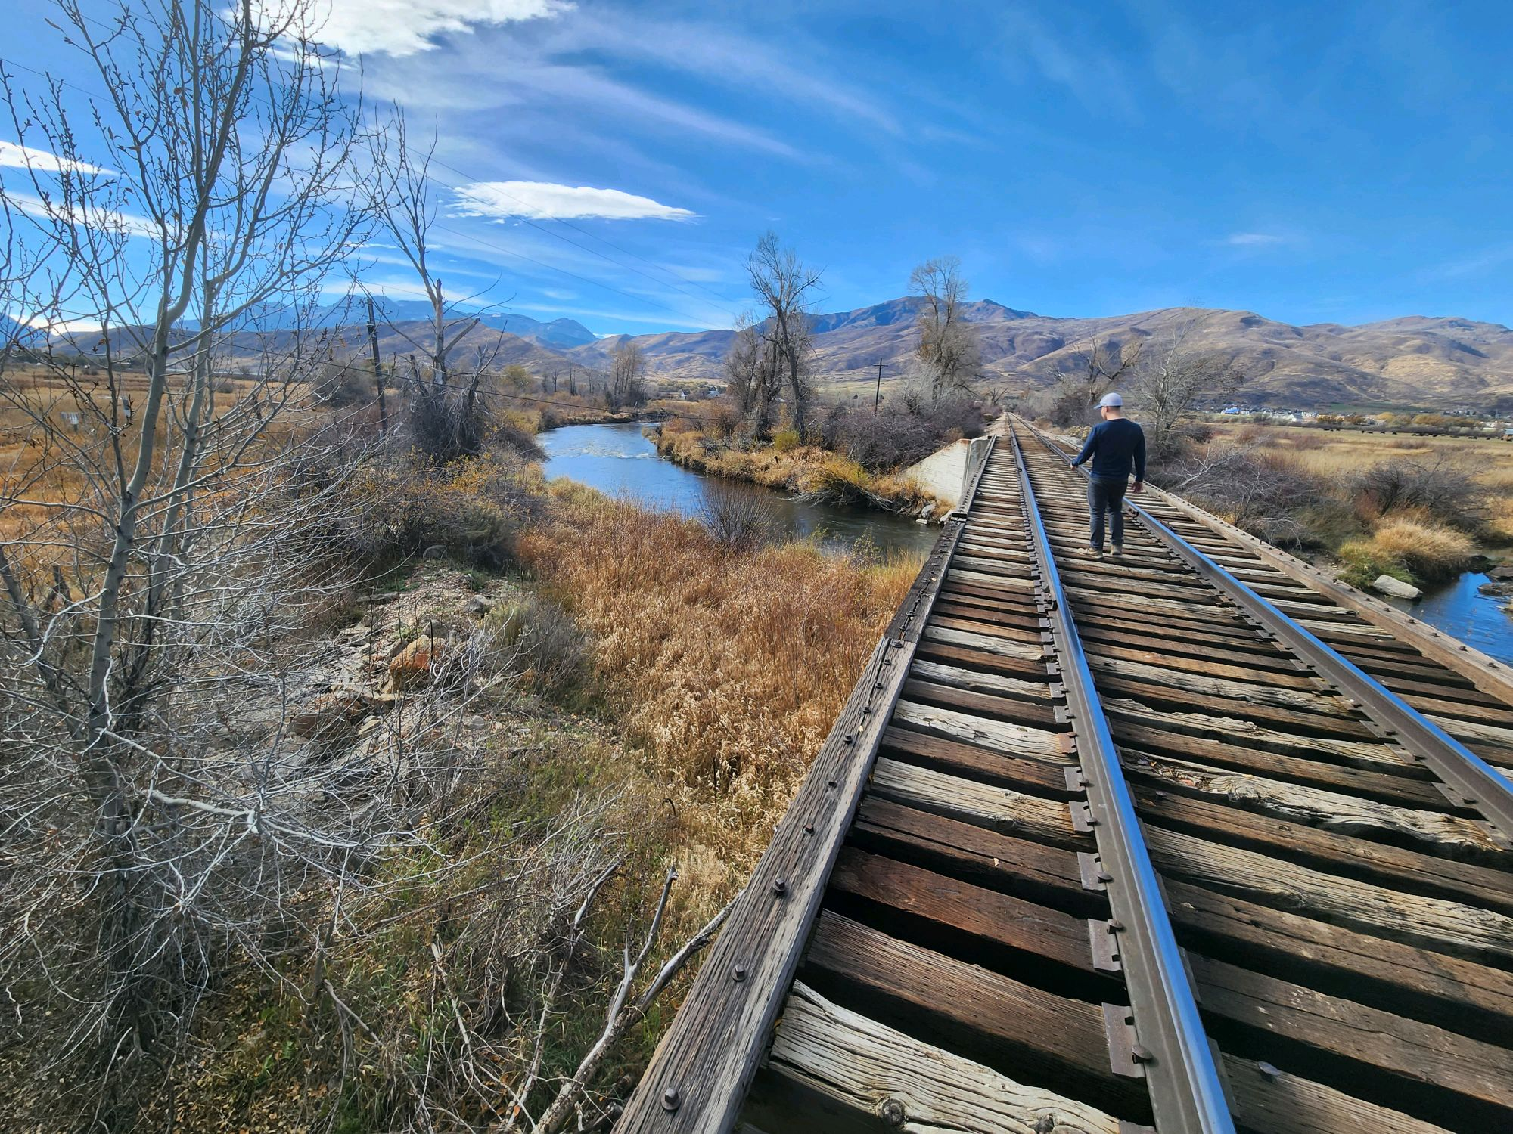
Figure 1: View of Proposed Bridge Location from Adjacent Railroad

Schedule

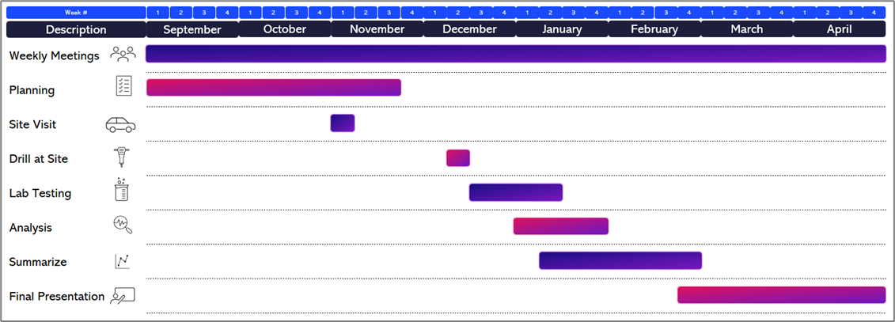
Figure 2: Project Schedule

The final project deliverables were:
- Boring logs from drill sites.
- Results from in-lab soil testing.
- Footing design recommendations.
All to be delivered upon completion of the project in this comprehensive report, scheduled for April 17, 2024, at the end of the BYU Winter ‘24 semester.

Assumptions & Limitations

Soil Assumptions
- Soil samples used in lab testing are representative of all the surrounding soil.
- The foundation will be placed near the boring locations.
- The water table at date of drilling was representative of standard conditions.

Foundation Assumptions
- See Appendix B for hand calculations with references to the sources for the assumptions that were made for footing calculations.
- Bridge assumed to be 110’ span x 12’ width.
- Assumed Dead Load = 97 psf.
- Assumed Live Load = 90 psf.
- Assumed Vehicle load per abutment of 20,000 lb.
- Assumed 3 base plates per abutment (6 total per bridge), equally spaced horizontally and vertically on each footing.
- Assumed base plate size of 12”x 6”
- Assumed vertical wind load of +/- 5.5 psf.
- Assumed horizontal wind load or 35 psf.
- Assumed bridge side area of 789 sf (this includes all openings and area of steel).
- Wind upload force assumed to be 20 psf.
- Excludes horizontal loads due to thermal expansion.
- Footing design excludes considerations to horizontal loads acting on each abutment due to horizontal wind forces.
- Assumed load combination of Pu=1.25(DC)+1.75(PL)+1.75(LL)+1(WS)+1(SL) from AASHTO Bridge design specifications table 3.4.1-1 and C.4.1-2.
- The outside diameter of split spoon sampler assumed to be 3”.
- The Inside diameter of split spoon sample assumed to be 2.5”.
- Based on the blow counts, the allowable bearing pressure(q_{all}) was calculated to be = 17.9 ksf; however, a more conservative bearing pressure of q_{all} = 3 ksf was used for footing design.
- Strength of concrete assumed to be f’_{c}= 4,000 psi.
- Strength of Steel assumed to be f_{y =} 60 ksi.
- The footing was designed as a block, excluding features such as a backwall height.
- The loads were assumed to be acting at the center of the footing in the transverse direction.

Design, Analysis & Results
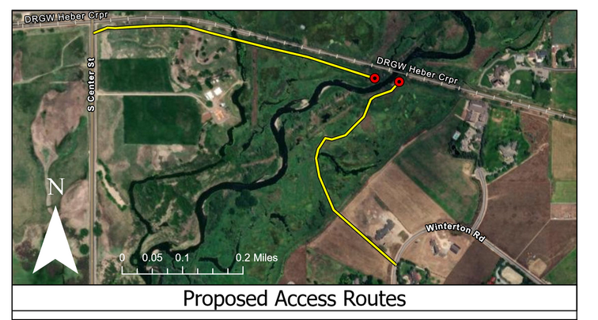
Geotechnical Design
Figure 3: Proposed Access Routes to Boring Locations
After a preliminary site visit, the first design step was to determine drilling locations. A site on each side of the river was determined suitable where the terrain was flat enough for drilling and devoid of large vegetation.
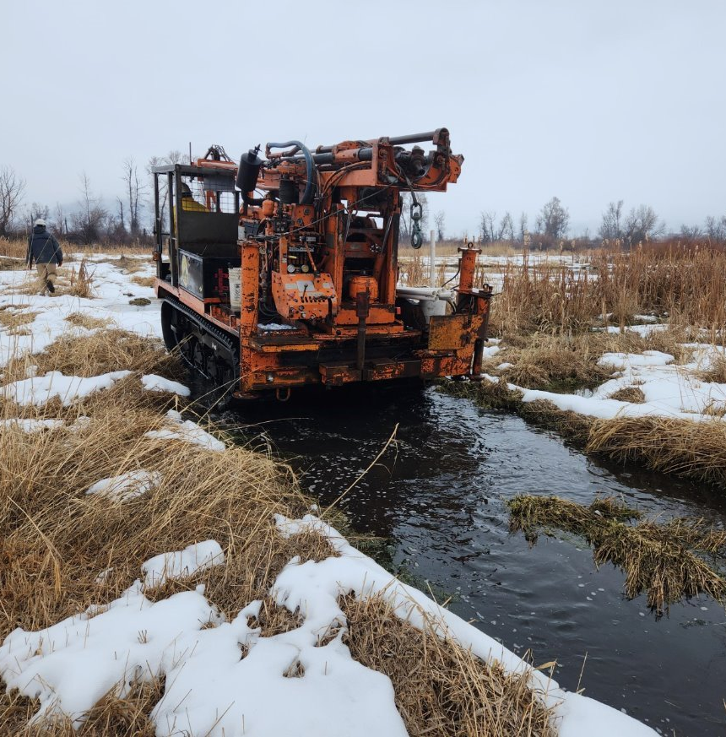
Each side of the river presented unique challenges for access. On the West Side, the boring location was inaccessible without crossing the Snake Creek River. On the East Side, the boring location was surrounded by muddy wetlands. Neither side could be accessed with a standard truck mounted drill rig. To solve the issue, South Slope Drilling was contracted to operate a track mounted drill rig that could traverse both the mud and the river.
Figure 4: Track Mounted Drill Rig on Site
Drilling was split between two days, one for each side of the river. During drilling, the team created boring logs to track visual descriptions and blow counts for each split spoon sample taken at 2.5-foot intervals, extending to 30 feet below ground surface. Ground water was observed to be 5 feet below ground level. Blow counts were corrected as seen in the hand calculations found in Appendix B. Samples were retrieved and returned to the lab for testing. Gradation tests were done on each sample to determine gradation.
Gradation testing was performed in two parts. First, for coarse materials with sieves ranging from 2” to No. 4. Then, for finer materials ranging from sieve No. 4 to No. 200. The gradation for the soils was consistent below the topsoil at both boring holes. Figure 6 displays the grain distribution curve created from the results of the gradation of material from hole B9 at 9 feet. The material was classified as poorly grained gravel with sand. This was determined to be suitable material for the necessary load bearing.
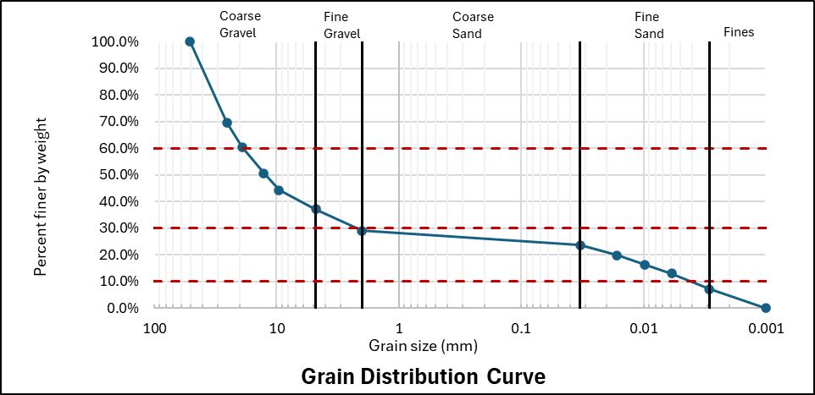
Figure 5: Grain Distribution Curve at 9 feet

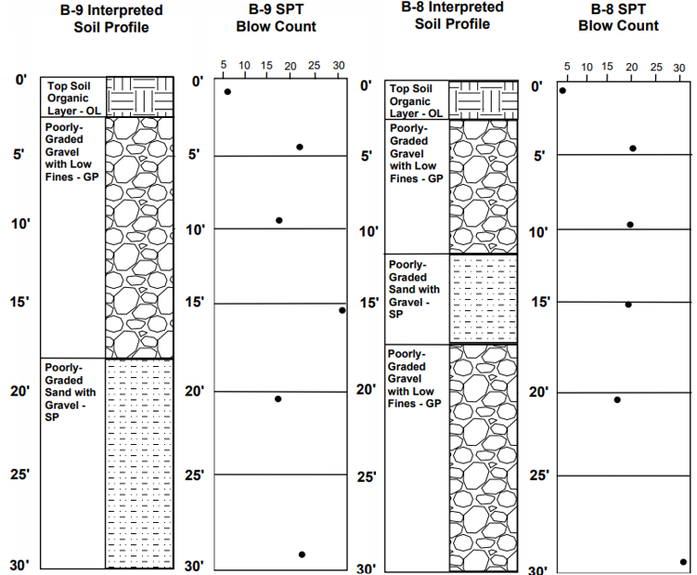

Figure 6: Boring Log
Bor

Foundation Design
The data shown in Table 1 is a summary of the loads that were used to for the footing design. The hand calculations in Appendix B explain the documents referenced to produce these reactions. See the assumptions and limitations section for clarification on the assumptions made to achieve these loads and the subsequent calculations. Based on these reactions, a load demand of 74.9 Kips was calculated at each of the 3 base plates per abutment. This load is acting in the vertical direction.
Table 1: Bridge Reactions
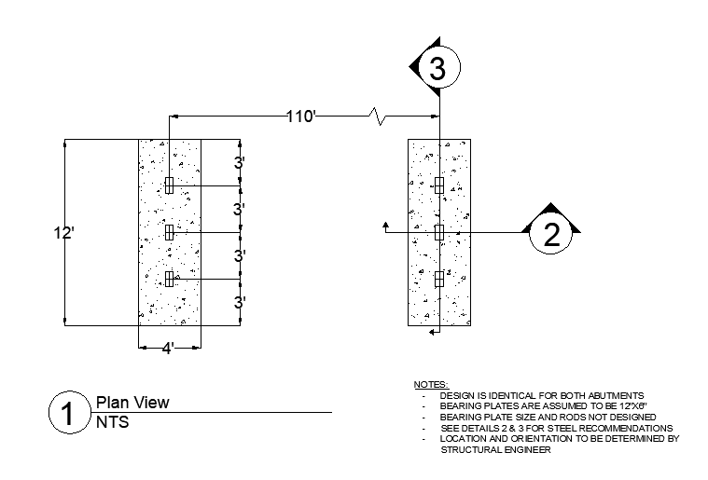
From the soils report, the blow count and the spoon sampler size were used to obtain the allowable bearing pressure. The bearing pressure considered shear failure with a factor of safety of 2.5 along with settlement limitation of one inch. Due to the high value of the allowable bearing pressure, a more conservative value was used of 3 ksf. The concrete compressive strength was assumed to be 4000 psi while the yield strength of the reinforcing steel was assumed to be 60,000 psi. These values. were then used to obtain the length, width, and depth of the proposed footing abutment. The drawings in Figure 6, Figure 7, and Figure 8 show the proposed dimensions of the footing, with a length of 12 ft, width of 4 ft, and a depth of 1.5 ft. Length and width were based on bearing capacity requirements while thickness was based on punching shear requirements. The footing shall reach a depth of embedment of 36” below ground surface to meet frost depth requirements.
Figure 7: Plan View
With respect to the steel requirements for the foundation, Figure 7, and Figure 8 depict the proposed bar type, count, and spacing. In all limit states, one way shear and punching shear, the calculated steel was found to be less than the minimum requirements for steel in the longitudinal and transverse direction at the top and bottom of the steel. As such, the minimum steel requirements were used. The minimum steel is 0.39 in^2/ft. Furthermore, it was sufficient to use #4 rebar, spaced every 6 inches for the transverse and longitudinal direction.

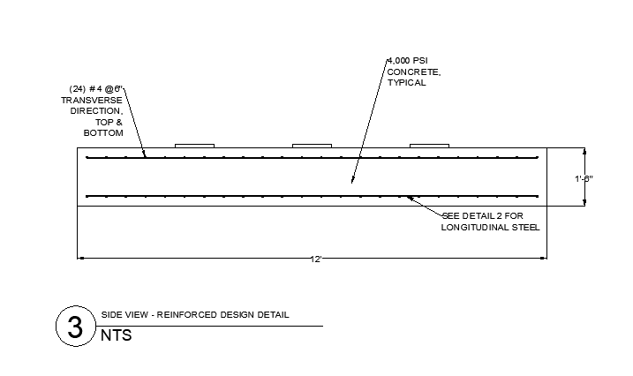
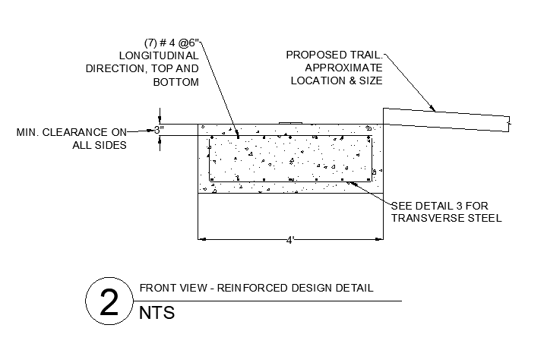
Figure 9: Front View
Figure 8: Side View

Related Issues
- Public Health:
        - This bridge is one piece of infrastructure that is going into the greater Heber trail system. The trail system will provide a way for the members of the community to get exercise.
- Safety:
        - While drilling, PPE was worn, and safety procedures were followed.
        - On project completion, foot and bicycle traffic will be reduced on nearby roads and the adjacent Heber Creeper Railroad. This will make recreation safer in the area for pedestrians and drivers.
- Sociocultural Factors:
        - The pedestrian trail and associated infrastructure will help members of the community connect through exercise. The ease of connection across the river by foot encourages the community to grow in unity.
- Environmental Factors:
        - On the first day of drilling at hole B-8, the eastern hole, the drill rig was found to have a leaking hydraulic line in preliminary inspection. This leak caused a risk of harmful chemicals reaching the wetland environment. To prevent contamination, that hydraulic line was not used, and the driller resorted to a slower method with a weaker pully. The leak was repaired before the next day.
        - During mobilization a representative of the EPA was on site to ensure the safety of the Columbia Spotted Frog. The path of access passed through a known habitat of the endangered species. She monitored the rig’s path and progress to ensure that the treads would not destroy the animals or their habitat.
- Economic Factors:
        - The completed pedestrian path may increase the desirability of homes in the area and raise the property value.
        - This trailway should also attract more visitors, bringing in revenue for local business such as the Heber Creeper sightseeing tour.

Lessons Learned
- Equipment Inspection Protocol:
  - It is imperative to conduct thorough equipment inspections before commencing any drilling operations. Failure to do so may result in unforeseen issues with safety or equipment and lead to delays and potential safety and environmental hazards.
- Regulatory Compliance:
  - When operating within federal lands, it is essential to ensure that all necessary permits are obtained well in advance. The process of procuring the required permits prolonged the drilling schedule by two months.
- Utilization of Excel Tools:
  - Developing Excel tools to streamline the calculation processes for foundation design proved to be invaluable. Implementing such tools facilitated faster and more organized computations. Regular consultations with our mentor further aided in overcoming initial challenges associated with the development of the foundation design.
- Application of Academic Knowledge:
  - The project provided an opportunity to bridge theoretical knowledge acquired in academia with real-world applications. By integrating foundation design principles and geotechnical engineering concepts learned in school, we gained practical insights into addressing on-site challenges.
- Soil Characteristics:
  - An understanding of the soil characteristics specific to the region, particularly in Utah, influenced our foundation design approach. We observed that the soil in this region exhibits favorable properties for foundation design, underscoring the importance of site-specific considerations.

Conclusions
We concluded that, beneath two feet of topsoil, the soil on site is suitable for bearing capacities exceeding the probable design load. The results of our field and in-lab gradation analysis support this statement. We classified the soil as poorly graded gravel with sand (GP). It should not experience significant shrink-swell because of the low fines content. From the results of the SPT blow counts, we calculated the allowable bearing pressure of the native material to be 5.5 kips per square foot (ksf) but used a conservative value of 3 ksf in design to consider variation in ground water level.
Views of the footing design drawings can be seen in Appendix A. Design loads were calculated using AASHTO Bridge design specifications table 3.4.1-1 and C.4.1-2, and bridge dimensions from Consor. The proposed minimum footing dimensions were calculated as a length of 12 ft, width of 4 ft, and a depth of 1.5 ft. To meet frost depth requirements, the bottom of footing will be embedded 36” below ground surface.

Recommendations
Before construction begins, it is advised that all topsoil and organic soil be removed beneath bridge abutments. The allowable bearing pressure has been set at a conservative 3 ksf, despite the possibility of higher pressures indicated by blow count analysis. For optimal design, the bridge abutments should have minimum dimensions of 12 feet in length, 4 feet in width, and 1.5 feet in depth. Additionally, the minimum steel requirements call for #4 rebar with 6-inch spacing for both top and bottom reinforcement.
We believe that the footing design presented in this document is sufficient to meet the design load of the proposed bridge plans. Furthermore, we suggest that the native soil should be suitable for bearing that load. The members of BYU Capstone Team 9 are unlicensed civil engineering students. Therefore, we recommend that all designs in this report be reviewed and revised by a licensed professional engineer before implementation.
In addition to technical recommendations, it's essential to assess and mitigate the environmental impact of construction on endangered frog species habitat near the proposed bridge site. Conducting a thorough environmental assessment and implementing measures to protect habitat and wildlife, including buffer zones and eco-friendly construction practices, are suggested. Collaboration with environmental experts can ensure compliance with regulations and foster community support for conservation efforts, demonstrating a commitment to both engineering and environmental objectives.

Appendix A: Resumes
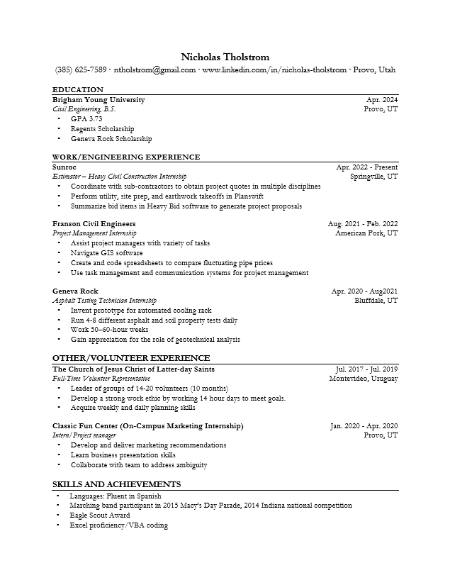

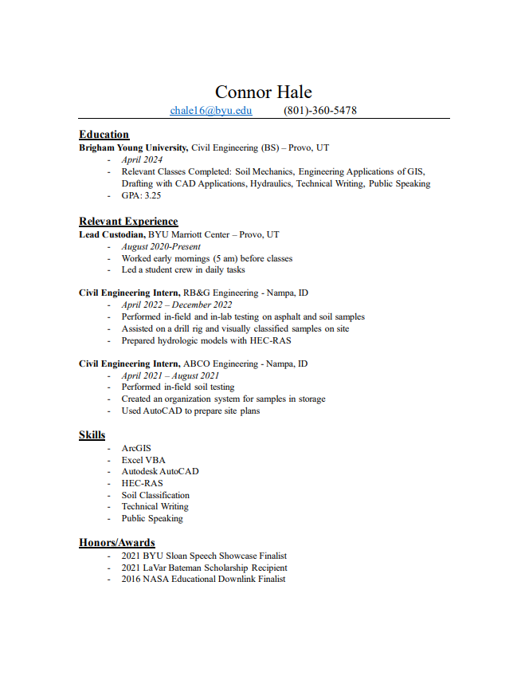


Appendix B: Footing Design Hand Calculations
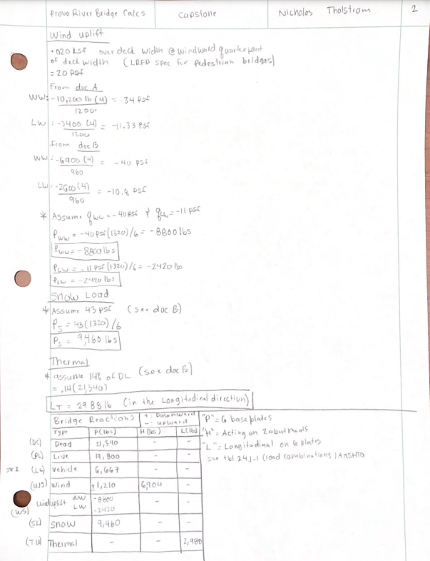

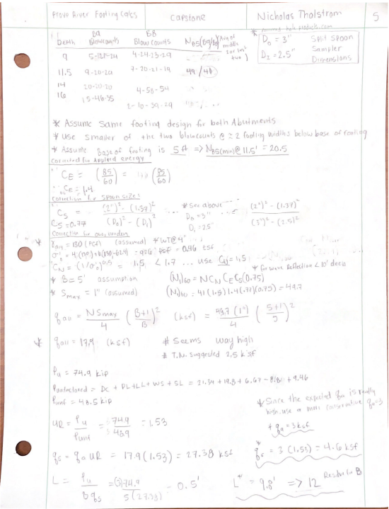

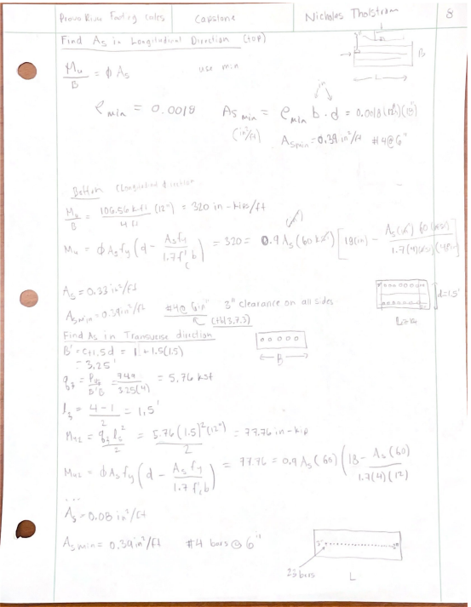

Appendix C: Gradation Distribution Plots
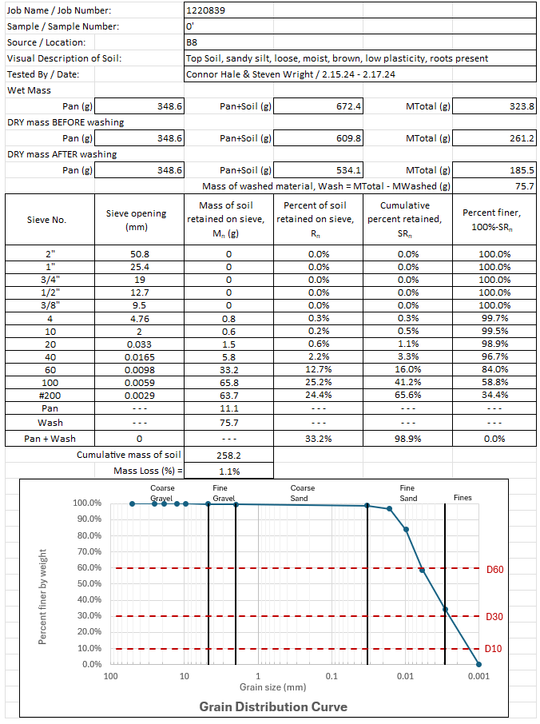
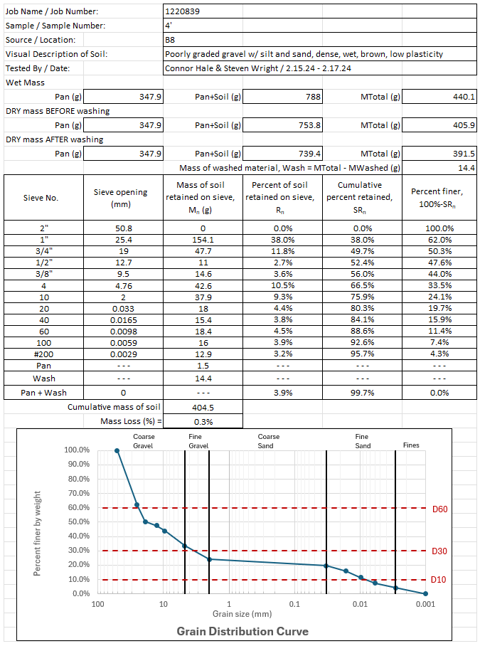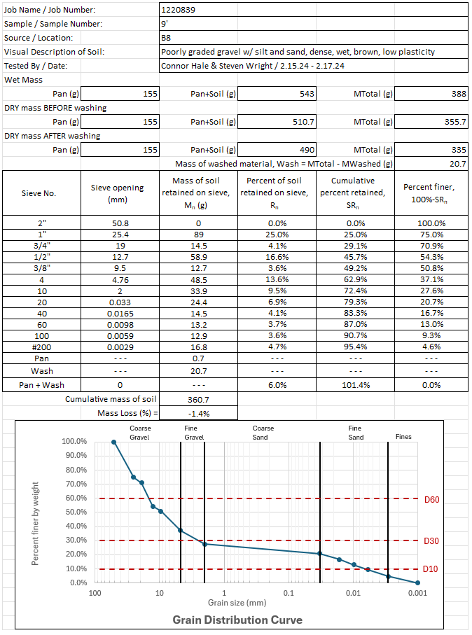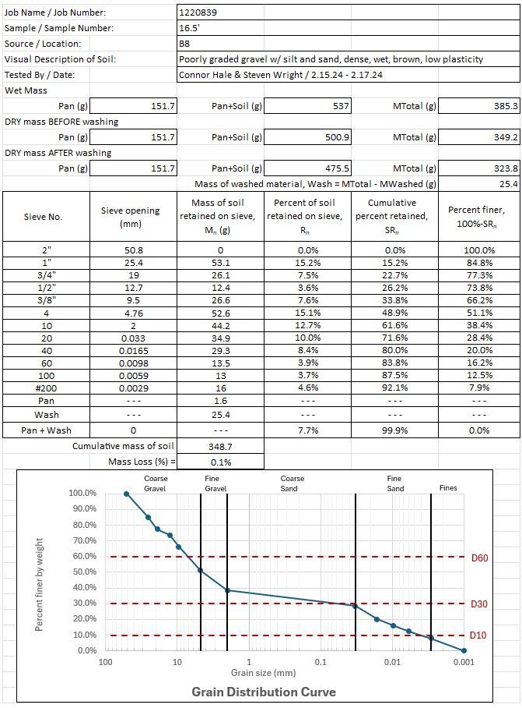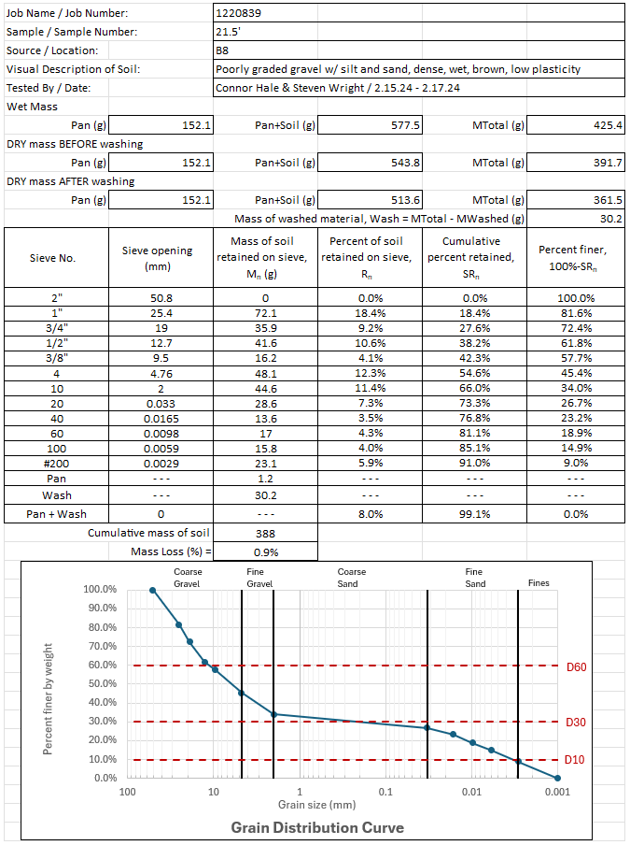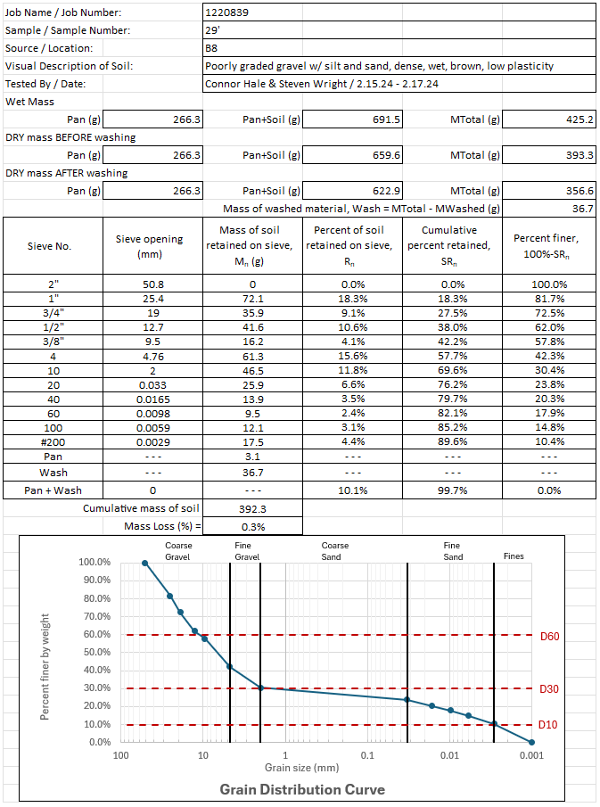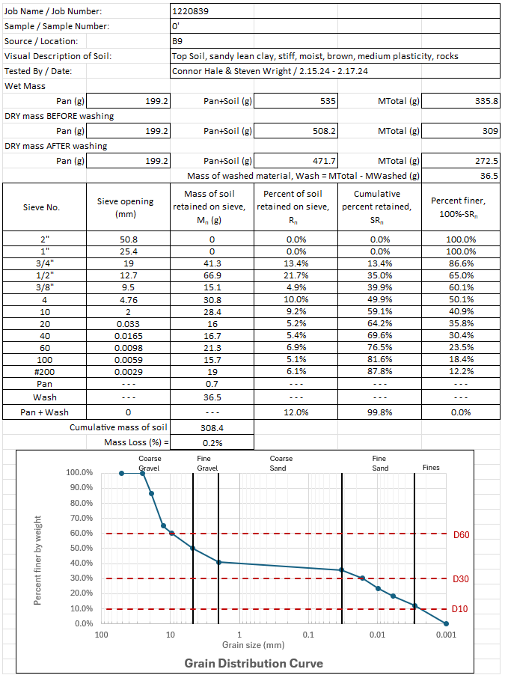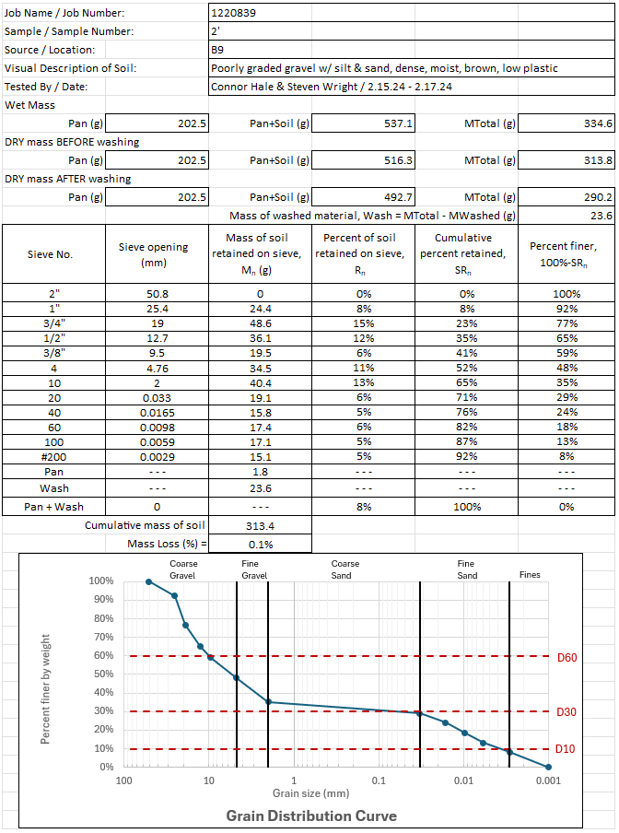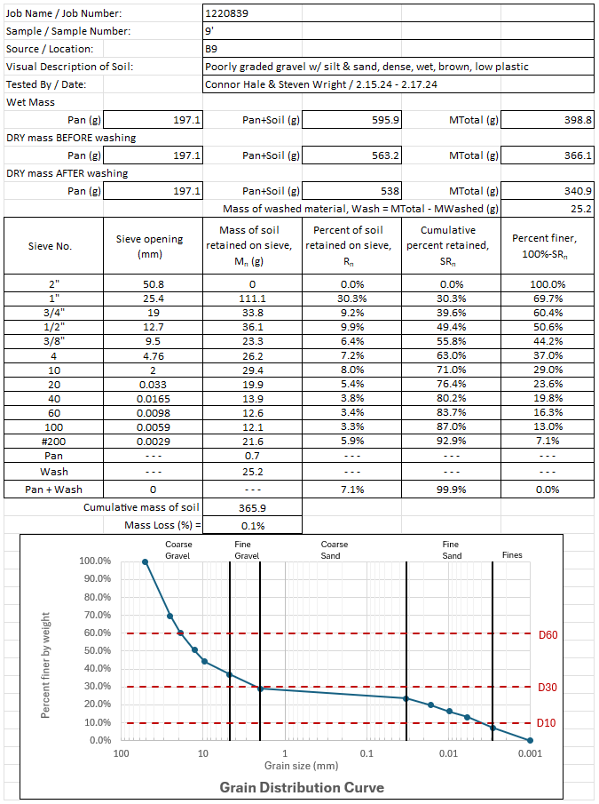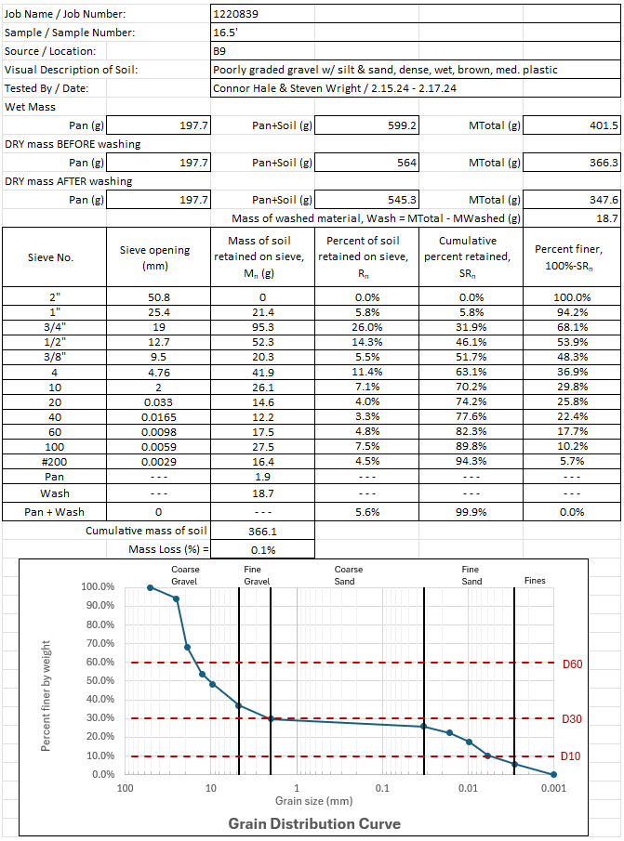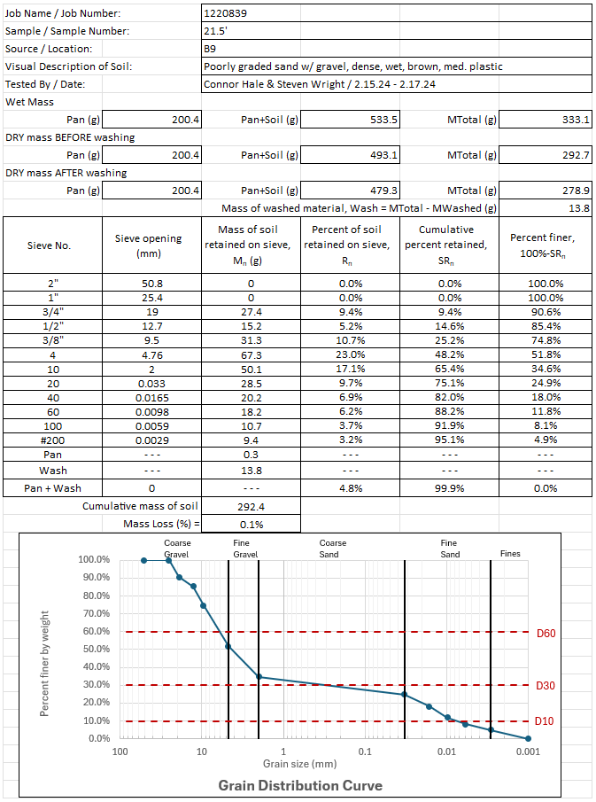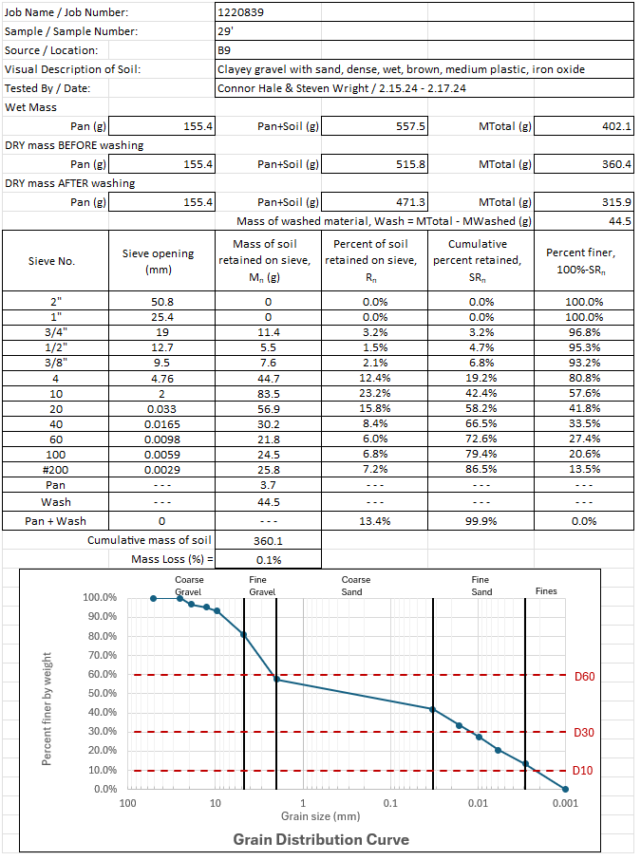

Appendix D: Boring Logs

